132nd
Hitz fm 93.9 BUNDABERG SHOW
2026
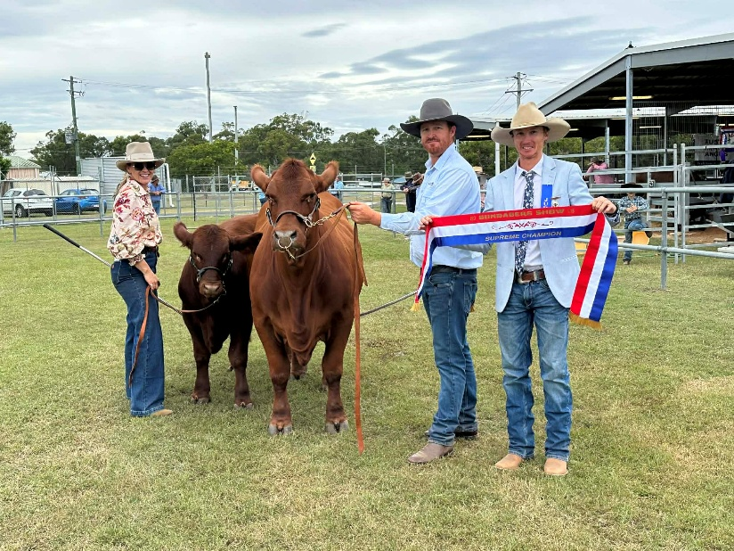


WEDNESDAY 27th May 2025 Supreme Champion Exhibit “Redline Ursulla”
THURSDAY 28th May Owner: Kristopher Dingle
FRIDAY 29th May

SECTION 3
STUD CATTLE
Schedule
BUNDABERG RECREATIONAL PRECINCT
PIC: QABX0038

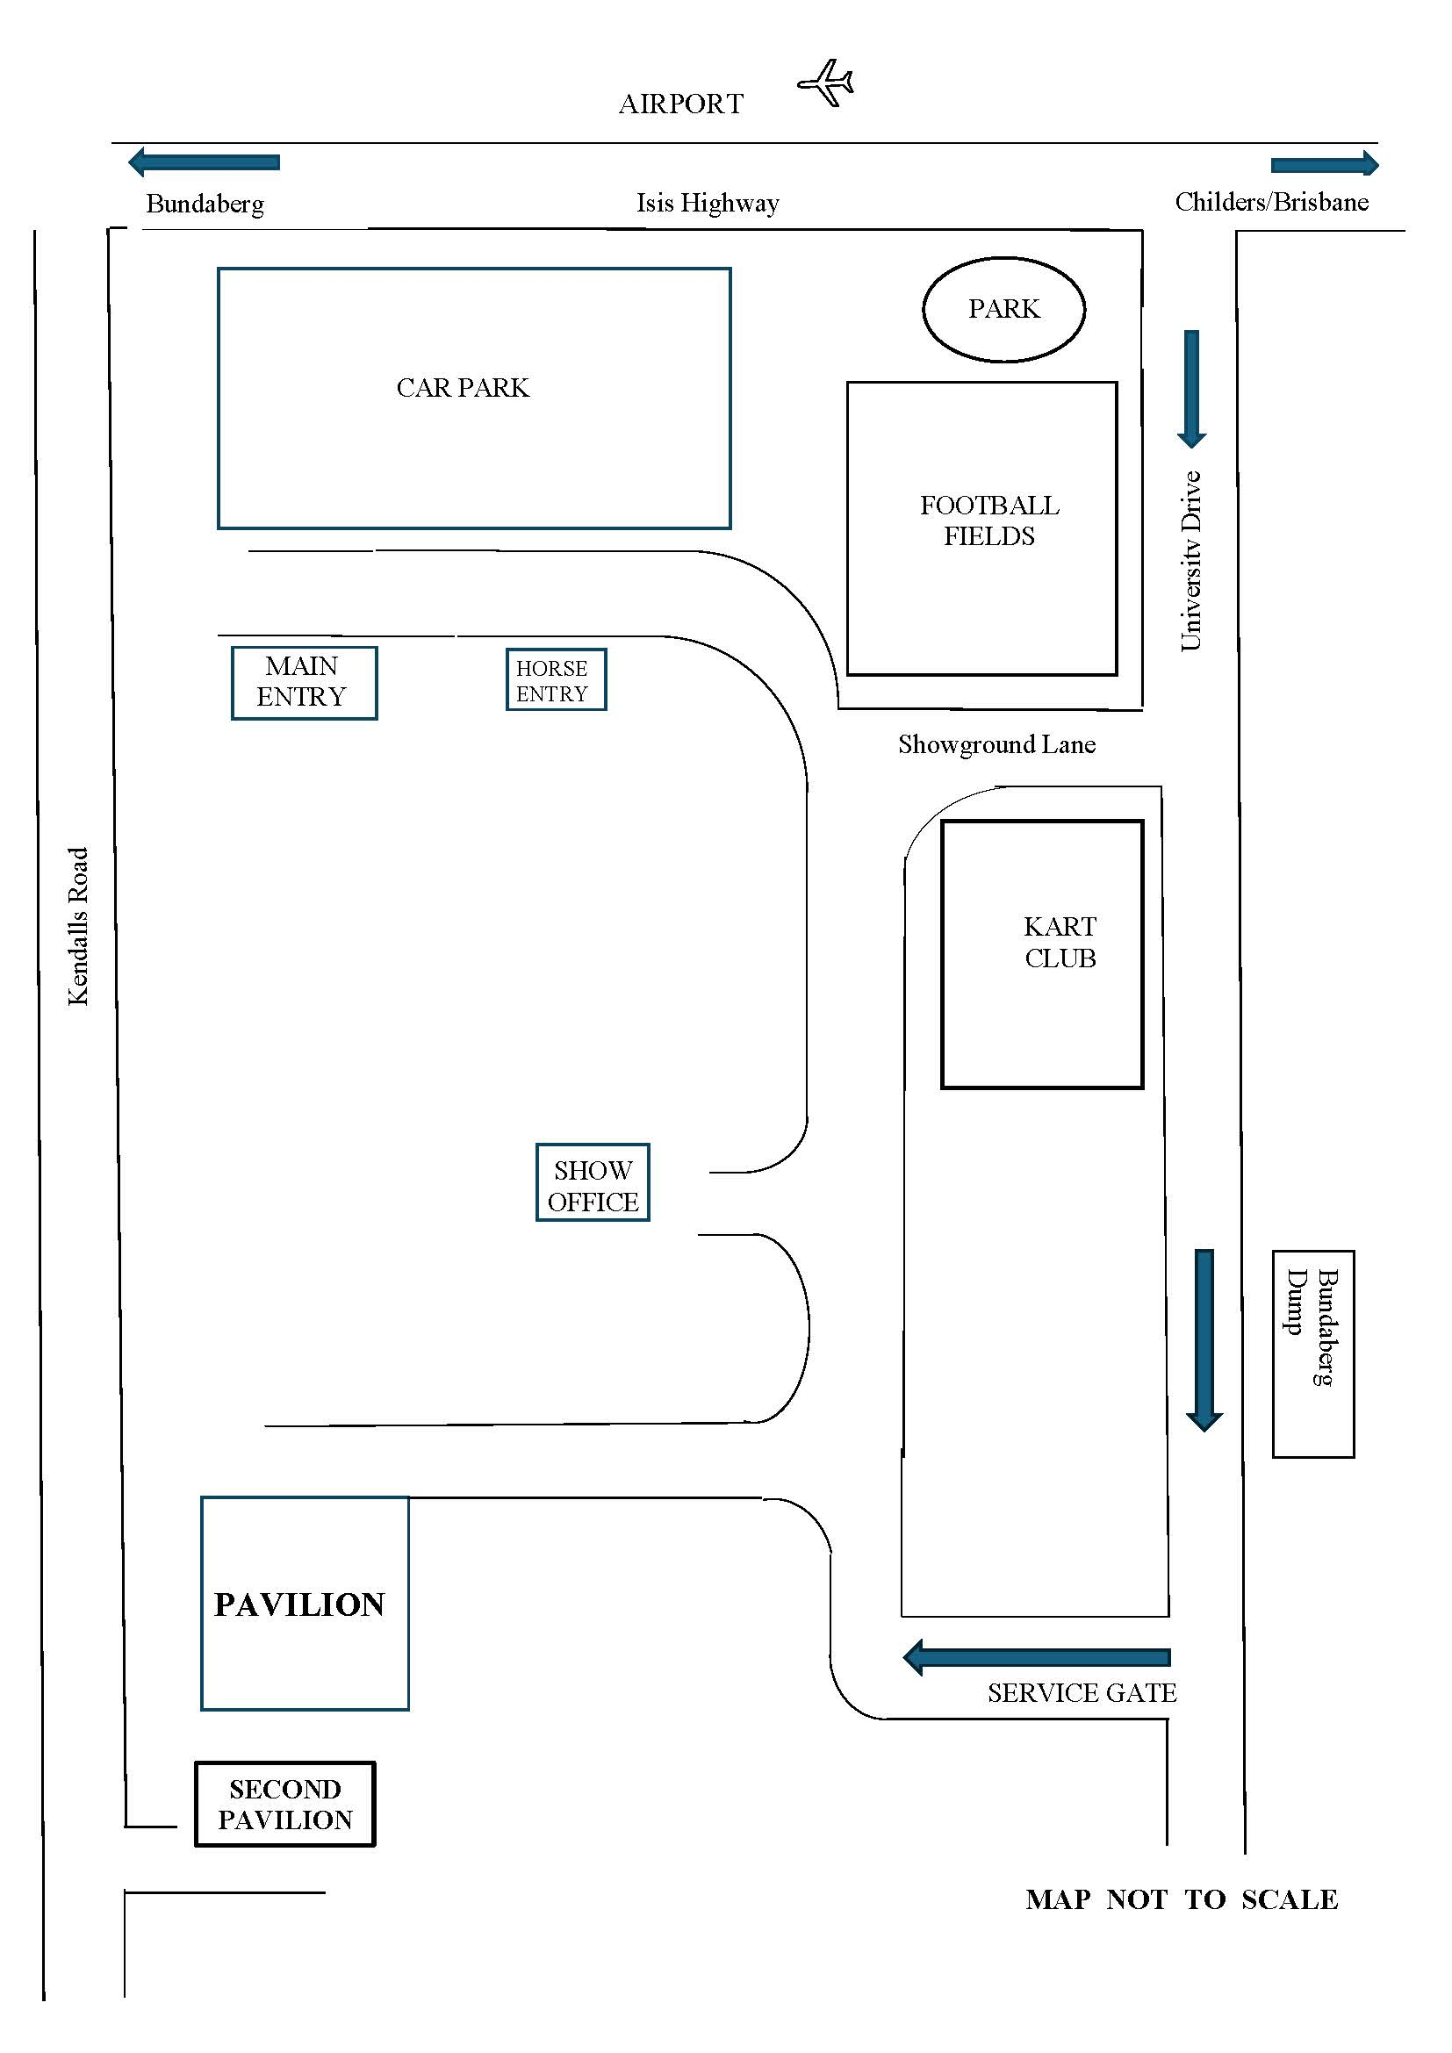

PRIVACY STATEMENT

The Information provided by Exhibitors Is used by the Queensland Chamber of Agriculture Associations Inc. and the Bundaberg A.P. & I, Society Inc. to organize , process and conduct competitions at the Bundaberg AP & I Society Inc show. By entering such competitions, you consent to your personal Information being used for this purpose Including this Information being made available to sponsors, breed Associations, the media, the public, promotional purposes. archival purposes, published in publications or as It Is otherwise required by Law.
All exhibitors have the right to access and alter personal information concerning themselves in the terms of the Privacy Act. This can be done by contacting the QCAS CEO or by writing to QCAS
WORKPLACE HEALTH AND SAFETY
All Queensland Chamber of Agriculture Societies Inc. affiliated Association Showgrounds are designated workplaces within the meaning of the
Workplace Health and Safety Act 2011 and exhibitors/competitors are required to ensure that they and all persons under their direction or control, including their contractors or subcontractors, comply with all requirements of the Act. The Queensland Chamber of Agriculture Associations Inc hold each exhibitor responsible to discharge Its obligations to provide and maintain a safe place and system of work during occupation by the exhibitor/competitor of any area of the affiliated Agricultural Associations Showgrounds/Precinct.
Each exhibitor/competitor will assess the risk to themselves, staff, volunteers, family, other exhibitors, Agricultural Society staff, show visitors, children and any person foreseeably affected by the presentation of their exhibit.
Exhibits will only be held and handled by competent persons whose experience Is known to the Exhibitor/ competitor.
The exhibitors/competitors are advised that the use of Primus Stoves, any heating or lighting appliances of a like character, or any naked light, ls strictly prohibited in Pavilions/stables/barns.
Any exhibitors/competitors Intending to bring electrical equipment to the Showgrounds/Precinct will be required to ensure that such equipment Is fitted with a residual current protection and that all electrical lead s, tools and appliances have been Inspected by a licensed electrical contractor and are currently tagged. The use of double adaptors is prohibited, and all power boards must also be tested and tagged.
All exhibitors/competitors will comply with the requirements of the ACT end Its Regulations and Standards In every respect. This Is essential for the safety of all exhibitors/competitors and the general public. The ACT Imposes very severe penalties in the event of noncompliance with its provisions. Any exhibitors/competitors who do not comply will not be allowed to exhibit at "Queensland Chamber of Agriculture Association. affiliated Shows".

BUNDABERG SHOW
GATE ENTRY FEES:
ADULT:------------------------------$20.00
STUDENT: 6 – 17 yrs:------------$10.00
CONCESSION:---------------------$10.00
OVER 75 YEARS :-----------------FREE
UNDER 6 YEARS:-----------------FREE

PRE-PURCHASE TICKET ONLY
FAMILY ONE DAY PASS $50.00
(Available until Tuesday 26th May 2026)
(Includes 2 Adult & 2 Children 17 yrs & under)

STUD BEEF – SECTION 3

The Bundaberg Show will be held on the 27th, 28th and 29th May 2026.

Judging will commence on Wednesday at 3:00pm

List of Cattle Committee Members

Bevan Glasgow – Chief Steward----------------- 0428 182 591

Neville Forman--------------------------------------0404 473 538

Paul Forman -----------------------------------------0422 181 557

Bundaberg Show Office------------------------------- 41550802
Fax----------41550804

ENTRIES CLOSE LAST MAIL POSTMARKED 5PM WEDNESDAY 20th MAY 2026
All entries to be emailed to secretary@bundabergshow.com along with Direct Deposit, or hand delivered to show office on University Drive.

TIMETABLE

Wednesday 27th May 2.00pm Junior Prime Cattle Judging
Junior Stud Cattle Judging
Thursday 28th May 7.45am Introduction of Judges and Committee
8.00am Cattle Judging commences
- Led Steers
- Bos Taurus
- Small Breeds
- Bos Indicus

Times and order of Judging may change. This will be decided at the discretion of the Judges and the Chief Steward. Any changes will be announced as soon as possible.
STUD BEEF – REGULATIONS

- Exhibitors must follow directions given at all times.
- Although Bundaberg is within the “Ticky Area” cattle are required to be presented at the showgrounds visibly free of ticks. The entry of any cattle not complying with the requirements will be at the discretion of the Cattle Committee.
- Cattle travelling from Bundaberg to “Tick Free Areas” must have certification from an Accedited Cattle Tick Certifier.
- All cattle must be accompanied by a valid NVD/Waybill.
- Cattle must not be introduced if they are from a property or herd in which Johne’s disease has been known, or suspected, to exist during the 5 year period prior to the Show.
- No bedding is to be brought onto the grounds (sawdust will be provided by the Show Society).
- All exhibits are to be registered with their respective Breed Society.
- All exhibitors to be at the Precinct no later than 6pm Wednesday 27th May 2026. Any exhibitors unable to meet this deadline are to advise the Chief Stewart not less than 24 hours prior to this time.
- All cattle must be unloaded on ramps provided on site.
CATTLE ARE TO BE IN THEIR ALLOCATED STALLS BY 7PM FOR SCANNING OF NLIS TAGS. THEY ARE TO BE ACCOMPANIED BY THE OWNER OR THEIR AGENT. WAYBILLS MUST BE PRESENTED WHEN REQUESTED BY THE SOCIETY APPOINTED SCANNERS.
- Stud Beef Cattle should not be admitted to the grounds unless thoroughly tractable. Stewards have the right to remove the animal if they deem that animal is a danger to public safety.
- All cattle must be the bona fide property of the exhibitor for not less than three (3) months prior to the show.
- The age of the cattle will be the actual age as of 1st MAY 2026.
- Weaned bulls under 12 months must have nose clips or rings, and bulls one year and over must have nose rings. Females over 6 months must have nose clips.
- All cattle are to have a neck strap fitted whilst stalled.
- Any animal not ready to parade on time may be prevented from entering the judging ring at the Stewards discretion.
- All exhibitors who participate in the show ring are to wear dust jackets and display the animals exhibit number at all times when their animal is presented to the Judge or while in the GRAND PARADE.
- (a). Supremes/Champions/Championship classes will receive their money at the Show Office after the GRAND PARADE on Thursday. (b). Please ensure you have your Prize Money Voucher & Grand Parade card to collect Prize Money for Supremes/Championship. (c). Any Supreme Champion/Champion/Championship not appearing in the Grand Parade will forfeit their prize money. (d). All other prize money will be paid from Ring Office daily. (e). Prize money not collected by Sat 30th May 2026 will be forfeited and returned to the Society’s funds. All prize money and entry fees include GST which is payable by all competitors whether registered or not for GST purposes.
- It is the responsibility of each exhibitor to ensure that the leaders of their stock in the judging ring and parades are capable of exercising control over the animal in their care. Children under 12 years of age leading cattle in the Grand Parade are to be accompanied by an adult over 18 years of age.
- Rules of Protest- In the event of a protest, properly lodged, the onus is on the exhibitor to provide proof of eligibility. The decision on the protest will be made by the Chief Cattle Steward and any two members of the Cattle Committee, together with a representative of the Show Society, and their decision will be final.
- In the event of any Champion being disqualified for any cause, the Champion will be selected from the remaining First Prize animals, together with the Second Prize Winner from the class which furnished the disqualified champion.
- It is forbidden to administer any prohibited drug or cause one to be administered in any way whatsoever. All drugs are to be administered with the permission of the Chief Steward or his deputy and by or under the supervision of the Show Society Veterinary Officer. Failure to follow this instruction may result in being debarred from the event. A prohibited drug is any substance capable of affecting the performance of behavior of an animal.
- A show steward may at any time direct the Society’s Veterinary Surgeon to take a sample of blood, saliva or urine from an exhibit for testing.
- Eligibility for Champion Awards – Junior Champion Awards:- All First place winners under the age of 20 months of the breed and sex will be allowed to compete.
Senior Champion Awards:- All first place winners 20 months and over of the breed and sex will be allowed to compete.
- Prize Money – All prize money, or vouchers for same, will be available 1 hour after completion of the program.
- Judges Discretionary Powers- In the case of a single entry in a class, the judge may award first or second or no prize at all, according to his or her own discretion.
- All exhibitors to have Public Liability Insurance and to have same endorsed for traveling to Shows. Minimum limit of indemnity is $10 million. In the absence of Public Liability Insurance, a declaration is available from the Show Secretary.
- Spare for assignment

WORK HEALTH & SAFETY ACT 2011 QUEENSLAND
- All Queensland Chamber of Agricultural Society Inc. affiliated Association Showground’s are designated within the means of the Work Health & Safety Act 2011 & Regulations and exhibitors/competitors are required to ensure that they and all persons under their direction or control, including contractors or subcontractors, comply with the WH&SQ Act 2011section 28 - 30
- Each exhibitor/competitor should look for any hazard & risk that may occur when presenting their exhibit. If hazards & risks are found these should be reported to the Show Committee/Organisers as soon as possible
- Hazards & Risks identified by exhibitors/competitors should be eliminated/controlled as far as practicable in consultation with the Show Committee/Organizers using risk management methodology(Risk Assessment)
- Exhibits shall only be held and handled by persons deemed to be competent by the Exhibitor/Competitor or Committee (written proof may be required)
- All electrical equipment shall be tested & tagged by a competent person/persons
- All exhibitors/competitors shall comply with the requirements of the WH&S Act 2011 and its Regulations and Advisory Standards where applicable.
- Spare for assignment DISCLAIMER
- The information contained in the Competitions Schedule is gathered for the purpose of providing information to Exhibitors and show patrons. The information is a compilation of information provided by third parties and the Queensland Chamber of Agricultural Associations Inc. and affiliated Agricultural Associations does not warrant its accuracy and advises that any such information may be subject to change or amendment occurring at any time and thereby making the information incorrect. Subject to the Queensland Chamber of Agricultural Associations Inc. legal obligations and responsibilities, if you require confirmation of any information please contact the QCAS Office.
- Spare for assignment

Useful Information for Cattle Exhibitors

Bedding for Cattle- Pine shavings or sawdust will be spread in each stall before the arrival of the Show Cattle.
Camping during the Show- Cattle exhibitors and/or their staff are welcome to camp on the grounds. A camping fee of $40 per campsite will apply for the duration of the show. Please add your required camping fees to your nomination fees.
Entry to the Show- All persons must pay at least once to enter the Show. Pass-outs will be available for campers at the Cattle Office and can be used to re-enter the grounds at the University Drive gates only.
Any Exhibitor wishing to sponsor a class in the cattle section are welcome to do so. Please indicate this on your entry form.

The Bundaberg Recreational Precinct is situated on Childers Road opposite the Airport

ARRIVING VIA SOUTH KOLAN/CEDARS CROSSING
Travel along the Bundaberg – Gin Gin Road and turn Right at the South Kolan Holel onto Hill End Road. Turn left onto Cedars Road and continue through to Childers Road. Turn Left onto Childers road and follow direction as per Arriving via South Bundaberg.
ARRIVING VIA SOUTH BUNDABERG
If entering Bundaberg from the south via Childers Road you will pass the Ring Road intersection on the right. Continue along Childers road towards town for a further 1kms. University Drive will be on the left hand side opposite the airport.
ARRIVING VIA NORTH BUNDABERG
If entering Bundaberg from North Bundaberg drive over the Don Tallon Bridge and turn Right onto Takalvan Street. Continue along Takalvan Street for 2.5kms, you will see the airport on the left and we are on the right. DO NOT turn into Kendalls Road continue on to the next road on the right. This is University Drive.

All entry is via the University Drive gate.
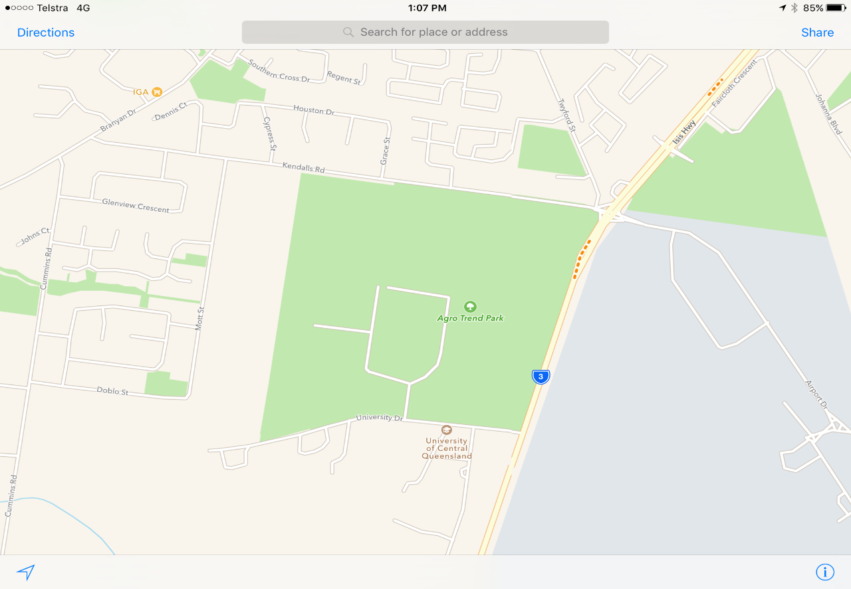

We are here

Entry via University Drive

The President of the Bundaberg Show Society, and the Cattle Committee
Members, gratefully acknowledge the many donations pledged and assistance given
toward the 2026 Show. Without your support it would not be possible
to run a successful show. Please accept our sincere THANK-YOU
one and all.

JUNIOR EVENTS
Young people who wish to compete in the Paraders and Judging events, are required to nominate by giving their names and ages (age as at 1st May 2026) to the Chief Steward. The announcer will call for nomination when ready. Differing age groups will be judged separately, if sufficient nominations are received. The highest overall point’s scorer over the age of 15 years, in the Parader’s and Judging events will be eligible to compete in the Regional Final to be held at Gin Gin.

JUNIOR PRIME CATTLE JUDGING

Prize Money: - 1st-------$40 Entry: - Free
2nd------$25
3rd------ $15
Champion Junior Judge-----$100
Reserve Champion Junior Judge-----$60

JUNIOR STUD CATTLE JUDGING

Prize Money: - 1st----$40 Entry: - Free
2nd----$25
3rd----$15
Champion Junior Parader ----$100
Reserve Champion Junior Parader ---- $60

LED STEER or HEIFER JUDGING

Any animal of any breed or cross breed, is eligible to enter these sections.

Prize Money: - 1st----$90 Entry: - $10 per entry per class
2nd---$55
3rd----$35

3/1 Led Steer or Heifer- Milk tooth up to and including 349kg.
3/2 Led Steer or Heifer- Milk tooth 350kg and over.

CHAMPION LED STEER OF HEIFER-----$30
RESERVE CHAMPION LED STEER OR HEIFER-------$20

BOS TAURUS JUDGING

Prize Money:- 1st ----- $40 Entry Fee: - $15 each
2nd -----$25
3rd -----$15

3/5 Bull – Under 12 months.
3/6 Bull – 12 months and under 16 months.
3/3 Bull - 16 months and under 20 months.

JUNIOR CHAMPION BULL -------------$30
RESERVE JUNIOR CHAMPION BULL -----$20

3/6 Bull - 20 months and under 24 months.
3/7 Bull - 24 months and under 30 months.
3/8 Bull - 30 months and over.

SENIOR CHAMPION BULL--------$30
RESERVE SENIOR CHAMPION BULL-------$20

GRAND CHAMPION BULL---------$250

3/12 Female - Under 12 months.
3/13 Female – 12 months and under 16 months.
3/14 Female - 16 months and under 20 months.

JUNIOR CHAMPION FEMALE-----------$30
RESERVE JUNIOR CHAMPION FEMALE------$20

3/17 Female - 20 months and under 24 months.
3/18 Female - 24 months and under 30 months.
3/19 Female - 30 months and over.

SENIOR CHAMPION FEMALE----------$30
RESERVE SENIOR CHAMPION FEMALE-------$20

GRAND CHAMPION FEMALE-------$250

3/23 Sire’s Progeny Group – Consisting of 3 animals.
3/24 Breeder’s Group – Consisting of 3 animals bred by exhibitor of
both sexes

BOS TAURUS OVERALL CHAMPION EXHIBIT-------$250

SMALL BREEDS JUDGING

Prize Money:- 1st ----- $40 Entry Fee: - $15 each
2nd -----$25
3rd -----$15

3/26 Bull- Under 12 months.
3/27 Bull- 12 months and under 16 months.
3/28 Bull- 16 months and under 20 months.

JUNIOR CHAMPION BULL----------$30
RESERVE JUNIOR CHAMPION BULL------$20

3/31 Bull- 20 months and under 24 months.
3/32 Bull- 24 months and under 30 months.
3/33 Bull- 30 months and over.

SENIOR CHAMPION BULL----------$30
RESERVE SENIOR CHAMPION BULL-------$20

GRAND CHAMPION BULL---------$250

3/37 Female- Under 12 months.
3/38 Female- 12 months and under 16 months.
3/39 Female- 16 months and under 20 months.

JUNIOR CHAMPION FEMALE---------$30
RESERVE JUNIOR CHAMPION FEMALE-----$20

3/42 Female- 20 months and under 24 months.
3/43 Female- 24 months and under 30 months.
3/44 Female- 30 months and over.

SENIOR CHAMPION FEMALE---------$30
RESERVE SENIOR CHAMPION FEMALE------$20
GRAND CHAMPION FEMALE----------$250

3/48 Sire's Progeny Group- Consisting of any 2 animals.
3/49 Exhibitor's Group- Consisting of any 3 animals, both sexes.

SMALL BREEDS OVERALL CHAMPION EXHIBIT-------$250

BOS INDICUS JUDGING

Prize Money:- 1st ----- $40 Entry Fee: - $15 each
2nd -----$25
3rd -----$15

3/51 Bull- Under 12 months.
3/52 Bull- 12 months and under 16 months.
3/53 Bull- 16 months and under 20 months.

JUNIOR CHAMPION BULL--------$30
RESERVE JUNIOR CHAMPION BULL-----$20

3/56 Bull- 20 months and under 24 months.
3/57 Bull- 24 months and under 30 months.
3/58 Bull- 30 months and over.

SENIOR CHAMPION BULL--------------$30
RESERVE SENIOR CHAMPION BULL-------$20

GRAND CHAMPION BULL-----$250

3/62 Female- Under 12 months.
3/63 Female- 12 months and under 16 months.
3/64 Female- 16 months and under 20 months.

JUNIOR CHAMPION FEMALE----------------$30
RESERVE JUNIOR CHAMPION FEMALE------$20

3/67 Female- 20 months and under 24 months.
3/68 Female- 24 months and under 30 months.
3/69 Female- 30 months and over.

SENIOR CHAMPION FEMALE--------------$30
RESERVE SENIOR CHAMPION FEMALE-------$20

GRAND CHAMPION FEMALE-----$250

3/73 Sire’s Progeny Group – Consisting of 3 animals.
3/74 Breeder’s Group – Consisting of 3 animals bred by exhibitor of
both sexes.

BOS INDICUS OVERALL CHAMPION EXHIBIT-------$250
The Grand Champions of the Bundaberg Show
will then compete for the Supreme EXHIBIT of SHOW
Bundaberg Agricultural Pastoral & Industrial Society Inc.
ABN. 21 134 402 026
Indemnity to be signed by any competitor/exhibitor

I,……………………………………………………………………………………..

Of ……………………………………………………………………………………

………………………………………………….. Postcode …………………………

Telephone ………………………………. Facsimile ……………………………….

ABN ………………………………………………………………………………….

HEREBY AGREE TO:
- Indemnify Bundaberg Agricultural Pastoral & Industrial Society Inc. against any liability whatsoever for any injury, loss or damage sustained by me, my cattle or my equipment at this Show.
- Compete and exhibit at the Bundaberg Show at my own risk entirely.
- Forfeit any right to any claim, demand or action against Bundaberg Agricultural Pastoral & Industrial Society Inc. or related bodies arising out of the conduct of this Show.
- Declare my cattle and equipment are in sound condition.
- Consent to receiving any medical treatment including ambulance transportation the event organizers think desirable as required during the Show.
- I have read the contents and fully understand all details on this form. I am 18 years of age or over.

DATED AT …………………….. THIS…………….. DAY OF ……………….2026

………………………..………………… ………………………………………………
Competitor/Exhibitor Witness
As a parent of the Competitor/Exhibitor who is under the age of 18 years, I agree to the above for myself and on behalf of my child. I indemnify and will keep indemnified all people and corporations associated with the conduct of the terms referred to.

Dated at …………….……this ………..………….. Day of ……….…………….2026

………………………………….…….. ………………………………………….
Parent/Guardian Witness
Bundaberg
Show
STUD CATTLE ENTRY FORM

BREED: ________________________________STUD NAME: ______________________________

Entries close: Wednesday 20th May 2026
Deliver to Show Office, via University Drive or email secretary@bundabergshow.com.au along with direct debit details

CLASS | DATE of BIRTH | SEX | ANIMALS’ NAME & HERD BOOK NO. | FEES

CAMPING FEES: $40 per camp Site: _________________

Voluntary Sponsorship Donation (Optional): _________________

TOTAL: _________________

To the Secretary/Manager:
Subject to the By-laws and Regulations comprised in the model Uniform Prize Schedule compiled by the Queensland Chamber of Agricultural Societies, except where such may be modified or added to by the Rules, By-laws and Regulations of the Bundaberg A.P. & I. Society, all of which are deemed included herein as if inserted at length. I, the undersigned, make the above entries for the forthcoming show, the same being my bona fide property.

SIGNATURE: _________________________ ABN:___________________
Actual NUMBER of head being bought to the Show: _________

EXHIBITOR’S NAME: ________________________________

ADDRESS: __________________________________________

__________________________________________

PHONE NO: ________________________________

LED STEER or HEIFER ENTRY FORM
Deliver or email to:
Show Office, via University Drive
or
email secretary@bundabergshow.com.au
along with direct debit details
Bundaberg
Show

Entries Close: Wednesday 20th May 2026

CLASS | STEER/HEIFER | ANIMALS’ NAME & BRAND | FEES

CAMPING FEES: $40 per camp Site: _________________

TOTAL: _________________

To the Secretary/Manager:
Subject to the By-laws and Regulations comprised in the model Uniform Prize Schedule compiled by the Queensland Chamber of Agricultural Societies, except where such may be modified or added to by the Rules, By-laws and Regulations of the Bundaberg A.P. & I. Society, all of which are deemed included herein as if inserted at length. I, the undersigned, make the above entries for the forthcoming show, the same being my bona fide property.

SIGNATURE: _________________________ ABN:___________________
Actual NUMBER of head being bought to the Show: ____________

EXHIBITOR’S NAME: ________________________________

ADDRESS: __________________________________________

__________________________________________

PHONE NO: ________________________________

