**131st**

**Hitz fm 93.9**

**BUNDABERG SHOW**

**2025**

# **WEDNESDAY 28th May**

**THURSDAY 29th May**

**FRIDAY 30th May**

**Woodchop**

**Section 12**

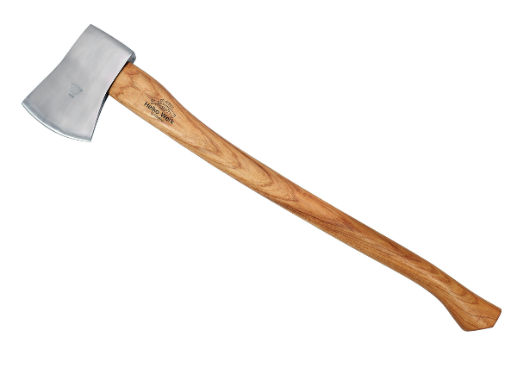

PRIVACY STATEMENT

The Information provided by Exhibitors Is used by the Queensland Chamber of Agriculture Associations Inc. and the Bundaberg A.P. & I, Society Inc. to organize , process and conduct competitions at the Bundaberg AP & I Society Inc show. By entering such competitions, you consent to your personal Information being used for this purpose Including this Information being made available to sponsors, breed Associations, the media, the public, promotional purposes. archival purposes, published in publications or as It Is otherwise required by Law.

All exhibitors have the right to access and alter personal information concerning themselves in the terms of the Privacy Act. This can be done by contacting the QCAS CEO or by writing to QCAS

WORKPLACE HEALTH AND SAFETY

All Queensland Chamber of Agriculture Societies Inc. affiliated Association Showgrounds are designated workplaces within the meaning of the

Workplace Health and Safety Act 2011 and exhibitors/competitors are required to ensure that they and all persons under their direction or control, including their contractors or subcontractors, comply with all requirements of the Act. The Queensland Chamber of Agriculture Associations Inc hold each exhibitor responsible to discharge Its obligations to provide and maintain a safe place and system of work during occupation by the exhibitor/competitor of any area of the affiliated Agricultural Associations Showgrounds/Precinct.

Each exhibitor/competitor will assess the risk to themselves, staff, volunteers, family, other exhibitors, Agricultural Society staff, show visitors, children and any person foreseeably affected by the presentation of their exhibit.

Exhibits will only be held and handled by competent persons whose experience Is known to the Exhibitor/ competitor.

The exhibitors/competitors are advised that the use of Primus Stoves, any heating or lighting appliances of a like character, or any naked light, ls strictly prohibited in Pavilions/stables/barns.

Any exhibitors/competitors Intending to bring electrical equipment to the Showgrounds/Precinct will be required to ensure that such equipment Is fitted with a residual current protection and that all electrical lead s, tools and appliances have been Inspected by a licensed electrical contractor and are currently tagged. The use of double adaptors is prohibited, and all power boards must also be tested and tagged.

All exhibitors/competitors will comply with the requirements of the ACT end Its Regulations and Standards In every respect. This Is essential for the safety of all exhibitors/competitors and the general public. The ACT Imposes very severe penalties in the event of noncompliance with its provisions. Any exhibitors/competitors who do not comply will not be allowed to exhibit at "Queensland Chamber of Agriculture Association. affiliated Shows".

**BUNDABERG SHOW**

GATE ENTRY FEES:

ADULT:-------------------------------$20.00

STUDENT: 6 – 17 yrs.:-------------$10.00

CONCESSION:----------------------$10.00

OVER 75 YEARS :------------------FREE

UNDER 6 YEARS:------------------FREE

**PRE-PURCHASE TICKET ONLY**

FAMILY ONE DAY PASS $50.00

(Available until Tuesday 27th May)

(Includes 2 Adult & 2 Children 15 yrs & under)

BUNDABERG A.P. & I SOCIECTY INC

PHONE 07 4138 7605

*Hitz fm 93.9 BUNDABERG SHOW*

*Thurs 29th May 2025*

*WOODCHOP ENTRY FORM*

Nomination and payments close: Thursday 15th May 2025 Queensland Axemen Association –

3 Chester Le Street, Blackbutt QLD 4314. The Stewards reserve the right to cancel any event if insufficient entries are received prior to the show or rearrange the program. Conducted under QAA RULES.

Must have purchased an entry ticket at the gate or online through our website.

www.bundabergshow.com.au

COMMENCING TIME 10.00 AM

|  |  |  |
| --- | --- | --- |
| CLASS | EVENT | NOMINATION  $ |
| 1 | A Grade Havey Dingle Memorial Championships  1 ST $400 2ND $300 3RD $200 4th $100 | $12 |
| 2 | B Grade Havey Dingle Memorial Championships  1 ST $400 2ND $300 3RD $200 4th $100 | $12 |
| 3 | C Grade Havey Dingle Memorial Championships  1ST $400 2ND $300 3RD $200 4th $100 | $12 |
| 4 | 2 Man Combo 10” **sb** 11 **uh** Teams Race. 12 Competitors  1st $50 ea competitor | $12 |
| 5 | VETERANS **sb** 10” Handicap  1ST $150 2ND $100 3RD $50 | $12 |
| 6 | VETERANS **uh** 11” Handicap  1ST $150 2ND $100 3RD $50 | $12 |
| 7 | **sb** 10 Handicap  1ST $150 2ND $100 3RD $50 | $12 |
| 8 | 11” **sb** Handicap  1ST $150 2ND $100 3RD $50 | $12 |
| 9 | 11” **uh** Handicap  1ST $150 2ND $100 3RD $50 | $12 |
| 10 | Junior Boys  1ST $40 2ND $30 3RD $20 4th $10 | $ 5 |
| 11 | 2 Man Crosscut 16”  1ST $120 2ND $90 3RD $60 Share | $5 |

**SB = Standing block**

**UH = Underhand**

***No refunds if change of mind or unable to attend.***

**PRIZE MONEY** Prize moneyto be collected from the Show Office during the Show from 2pm Thursday 29th May 2025, until 2pm Saturday 30th May. Office hours 9.00 – 4.00. Prize money NOT COLLECTED will be deemed a donation and returned to Society Funds. All prize money/entry fees contain GST whether registered or not for GST purposes

CHIEF STEWARD Mark Russell 0429 177 293