2025
131st

Hitz fm 93.9 BUNDABERG SHOW
WEDNESDAY 28th May
THURSDAY 29th May

FRIDAY 30th May
CLASS DAYS
Wednesday 28.5.25
Pony/Gall/Hack classes

Thursday 29.5.25
LED BREED CLASSES

New Aust Stock Horse
Program.
Wed Undercover arena
Thurs Main arena R3.

HORSE
SECTION 1
Location: Bundaberg Recreational Precinct, Isis Highway (Childers Road), Bundaberg.
Opposite Bundaberg Airport.
Grounds Entry: Turn into University Drive, first right Showgrounds Lane,
Follow around to Horse Gate.
Camp Site/ Stable Allocation displayed on sign boards at entrance gate & end Silver Stable Block.

Show Society Office: Ph 07 41387605
Email – secretary@bundabergshow.com.au
Web Page – www.bundabergshow.com.au
OFFICE HOURS - April 2025: Monday, Wednesday & Friday 9.00am - 4.00pm : May 2025: Monday to Friday 9.00am -4.00p

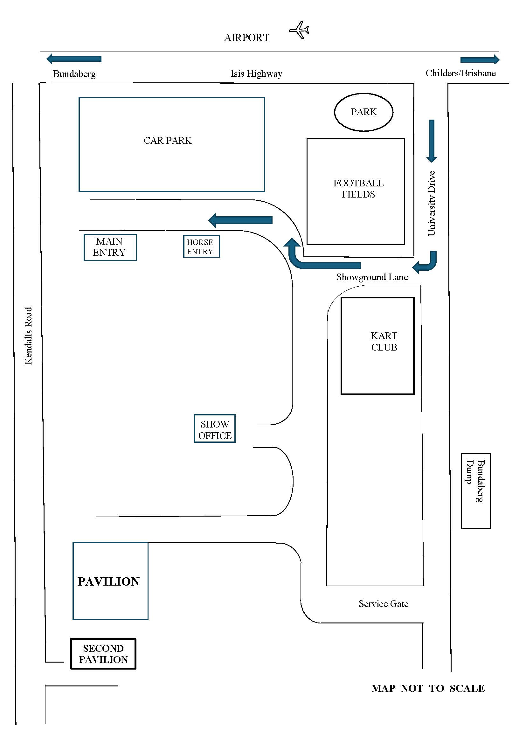

MAP OF HORSE VEHICLES ENTRANCE TO OVERFLOW ANNEX PARKING.

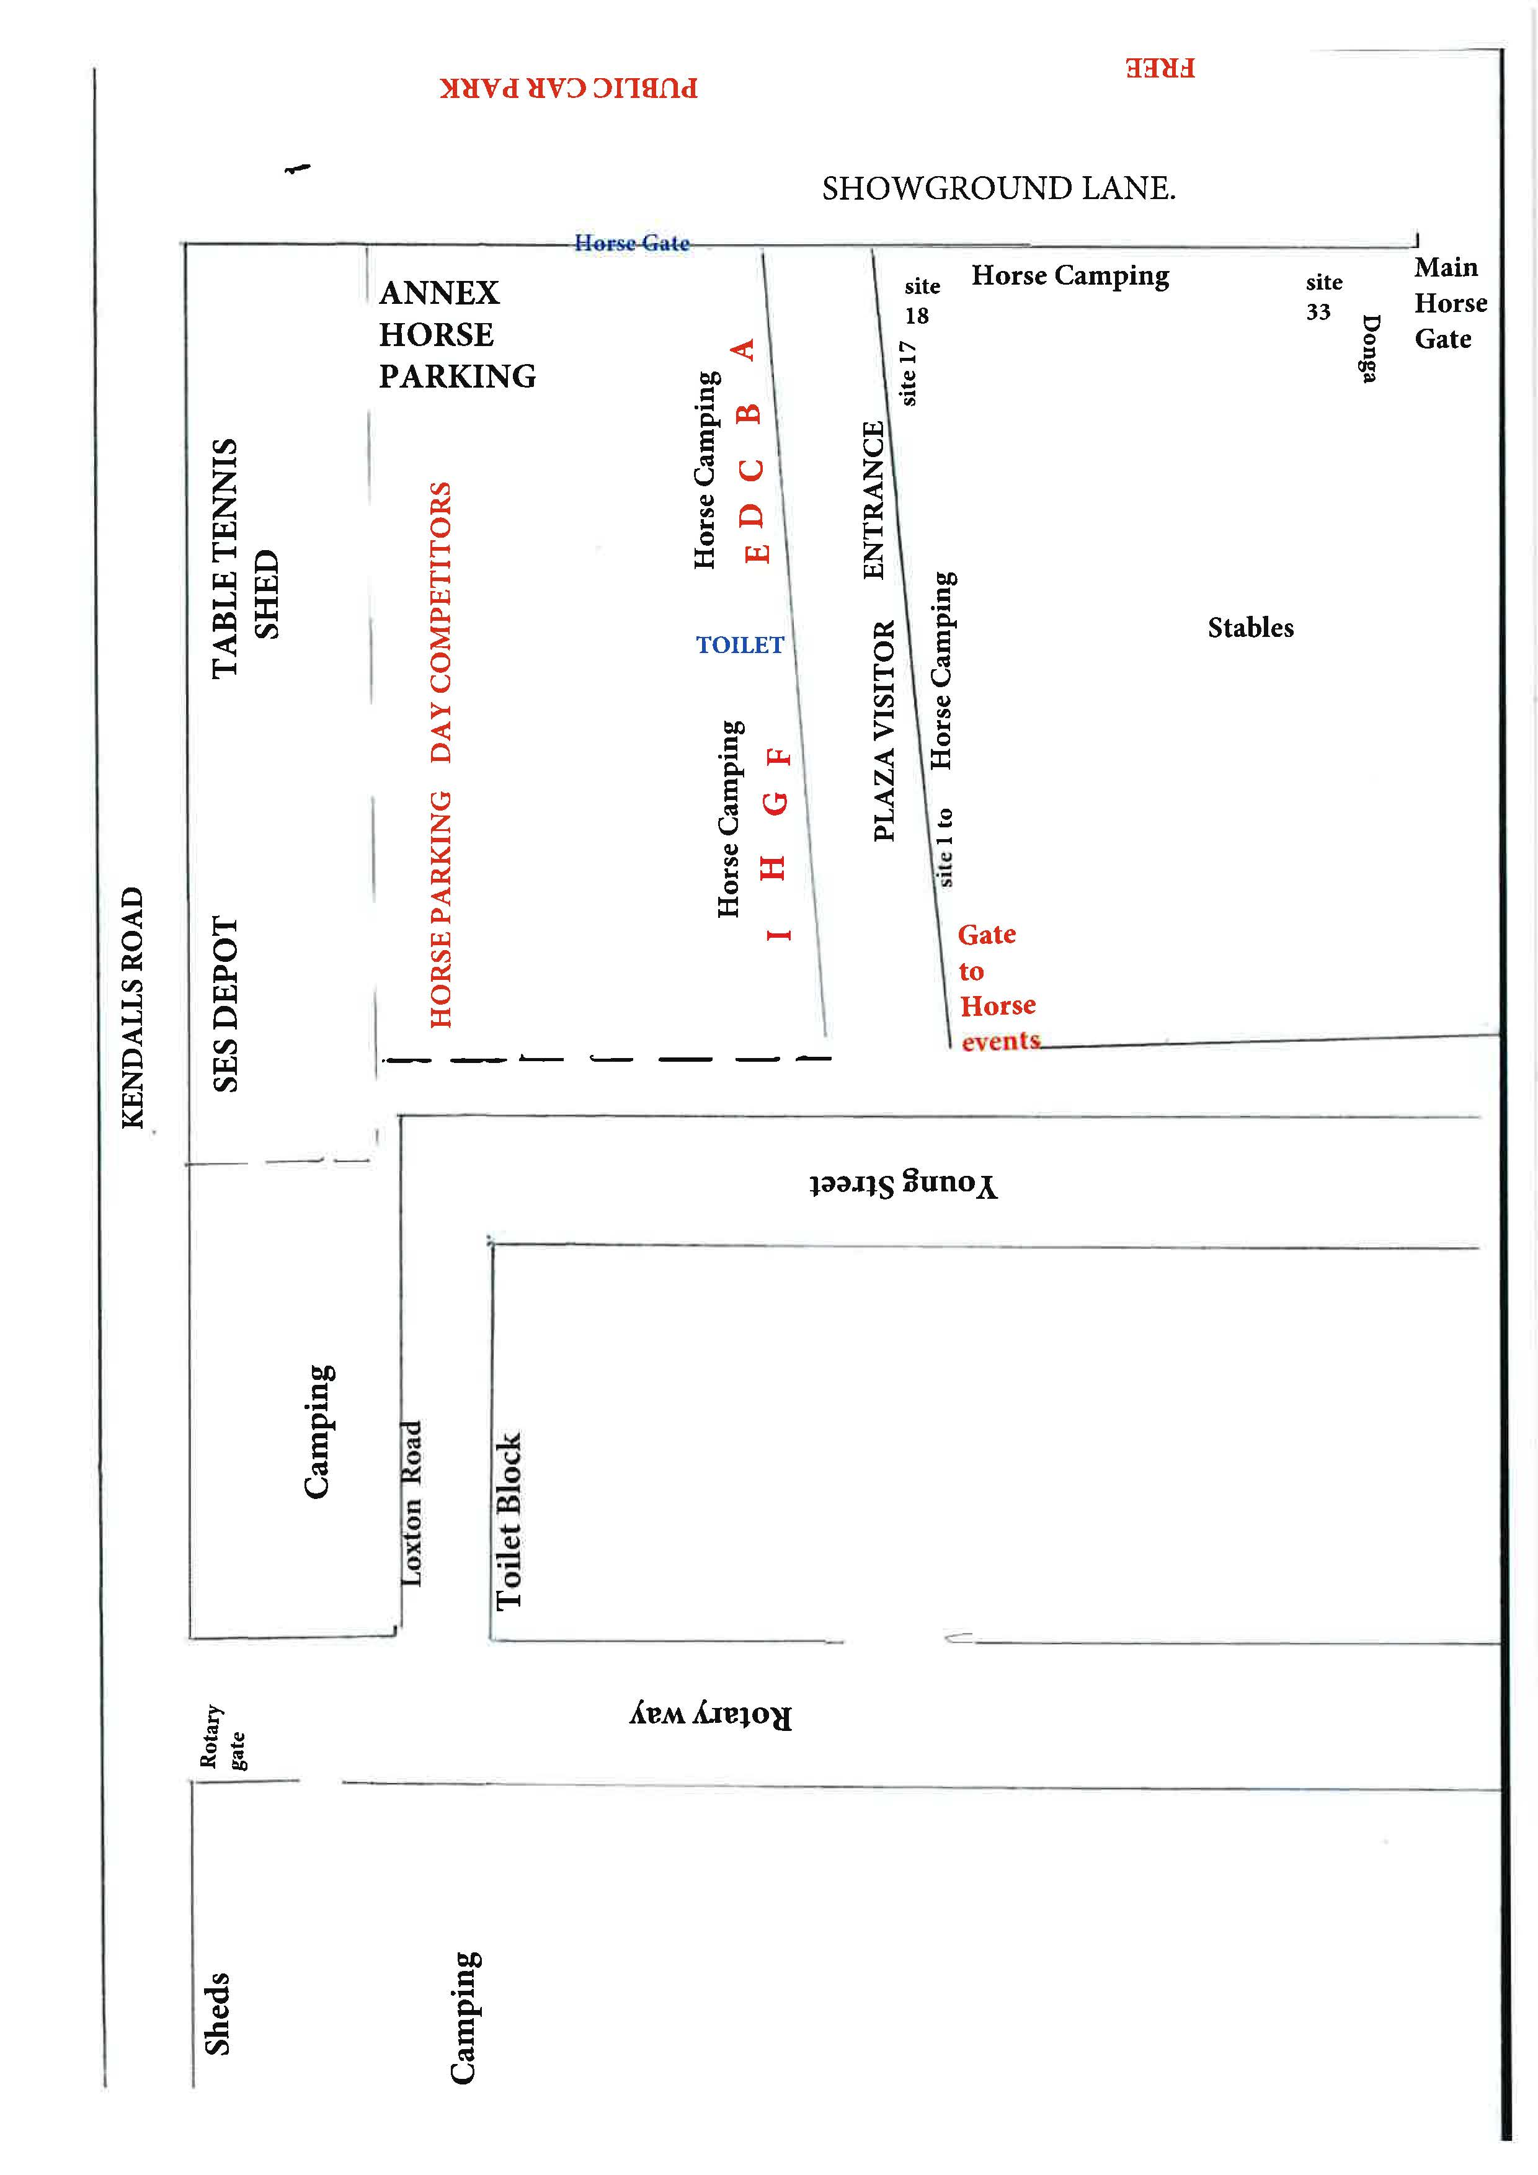

PRIVACY STATEMENT: Information provided by Exhibitors is used by the Queensland Chamber of Agriculture Associations Inc and the Bundaberg A.P. & I. Society Inc. to organize, process and conduct competitions at the Bundaberg A.P. & I. Society Inc show. By entering such competitions, you consent to your personal Information being used for this purpose. Including this being made available to sponsors, Breed Associations, the media, the public, promotional purposes, archival purposes, published in publications or as is otherwise required by Law. All exhibitors have the right to access and alter personal information concerning themselves under the terms of the Privacy Act. This can be done by contacting the QAS CEO or by writing to QAS.
W.P. H & S: All Queensland Chamber of Agriculture Societies Inc. affiliated Association Showgrounds are designated workplaces within the meaning of the Workplace Health and Safety Act 2011 and exhibitors/competitors are required to ensure that they and all persons under their direction or control, including their contractors or subcontractors, comply with all requirements of the Act. The Queensland Chamber of Agriculture Associations Inc hold each exhibitor responsible to discharge its obligations to provide and maintain a safe place and system of work during occupation by the exhibitor/competitor of any area of the affiliated Agricultural Associations Showgrounds/Precinct Each exhibitor/competitor will assess the risk to themselves, staff, volunteers, family, other exhibitors, Agricultural Society staff, show visitors, children and any person foreseeably affected by the presentation of their exhibit. Exhibits will only be held and handled by competent people whose experience is known to the Exhibitor/ competitor. The exhibitors/competitors are advised that the use of Primus Stoves, any heating & lighting appliances of a similar character, or any naked light, is strictly prohibited in Pavilions/stables/barns. Any exhibitors/competitors Intending to bring electrical equipment to the Showgrounds/Precinct will be required to ensure that such equipment is fitted with a residual current protection and that all electrical lead's, tools and appliances have been Inspected by a licensed electrical contractor and are currently tagged. The use of double adaptors is prohibited, and all power boards must also be tested and tagged. All exhibitors/competitors will comply with the requirements of the ACT end Its Regulations and Standards In every respect. This Is essential for the safety of all exhibitors/competitors and the general public. The ACT Imposes very severe penalties in the event of noncompliance with its provisions. Any exhibitors/competitors who do not comply will not be allowed to exhibit at "Queensland Chamber of Agriculture as BUNDABERG SHOW sociation. affiliated Shows".

GATE ENTRY FEES:
ADULT: $20.00
STUDENT: 6 - 17 yrs.: $10.00
CONCESSION: -$10.00
OVER 75 YEARS FREE
UNDER 6 YEARS FREE

PRE-PURCHASE TICKET ONLY
FAMILY ONE DAY PASS $50.00
(Available until Tuesday 27th May 2025)
(Includes 2 Adult & 2 Children 15 yrs. & under)



QLD GOVERNMENT
LOCAL GOVT FUNDING GRANT.

HITZ 93.9 FM RADIO, TAYCO.

Dear Competitor,

Welcome to the 131st Bundaberg Show.

READ YOUR SCHEDULE. NEW EVENTS ADDED.

Wednesday (Ridden events & Thursday Led events): Program RING 1 & 2 CHANGED:

New Australian Stock Horse events: Wednesday in undercover arena,

Thursday, Main arena Ring 3.

ALSO NEW EVENTS PLEASE READ THE SCHEDULE.

SHOW JUMPIING ON WEDNESDAY, 28th MAY --THURSDAY 29th May 2025.

NO GRAND PARADE. THE SHOW OPENING 6PM THURS.

CAMPING:

There is NO CAMPING IN FRONT OF DAY STABLES.

We have endeavored to accommodate all your requests regarding Camping and Stables. However, we need YOU to assist us with parking in allocated spaces. If you find it is not big enough please contact M. See Mob 0427 266 326 re possible change of location. No one likes to start the show with an argument.

SECRETARY'S OFFICE - The office is located at the Bundaberg Showground, 1 - 5 Childers Road (via University Drive), Bundaberg Telephone 07 41387605 Email -secretary@bundabergshow.com.au

SPONSORS:


 HORSE SCHEDULE RULES
RULES & REGULATIONS.COMPETITRORS ARE REQUESTED TO READ THESE REGULATIONS CAREFULLY.

ENTRY FEES: 1. Entry to all horse events will be by ticket only. You will purchase tickets to the value of the entry fee from Show Office and hand completed to Steward in the ring you are entering.
2. Entry Fees may be refunded only in special circumstances, and you must see Treasurer to get refund.
PAYMENT OF PRIZE MONEY:
3. Supremes/Champions/Championship classes will receive their money at the Show Office
4. Please ensure you have your Prize Money Voucher to collect Prize Money for Supremes/Championship.
5. All other prize money will be paid from Ring Office daily.
6. Prize money not collected by Sat 31st May 2025 will be forfeited and returned to the Society’s funds.
7. All prize money and entry fees include GST which is payable by all competitors whether registered or not for GST purposes.
DISPUTES: 8. If a dispute arises as to the age of a competitor, the only proof of age accepted will be a
birth certificate.
9. No dispute to be considered whilst the event is in progress. Protests are to be lodged in writing after the event has been completed and must be handed to the Show Office, accompanied by a fee of $50 within 30 minutes of completion of the event. Dispute Committee decision will be final.
GENERAL: 10. The show is conducted under the rules and regulations of Bundaberg A.P. & I. Society Inc.
And Qld Agricultural Societies.
11. Measuring Steward is available if required.
12. All STALLIONS/COLTS, two years & over must be led in a bit. The handler/rider must
have attained the age of 18 years on the day of the show.
13. All entries must be registered with the applicable Breed or Registered Societies or recorded in accordance with the rules of the respective breed society. Registration papers are required. NO REGISTRATION, NO ENTRY.
14. Competitors must wear CORRECT ATTIRE. Approved riding helmets AS/NZ/3838 2006 onwards. ARB HS 2012 provided they are SAI Global marked and riding boots essential. Jeans and T Shirts are not considered suitable attire.
15. No ring shall be required to wait for any competitor who may be competing in another ring.
16. An Exhibitor shall ensure that the horse and competitor are entered and shown only in correct class.
17. If in the opinion of the Judge, any horse or pony is entered in the wrong class, the Judge shall have the power to classify it in the correct class.
18.The age of a horse shall be calculated from 1st August in the year it is foaled.’
19. Stewards reserve the right to alter any event in the schedule.
20. Stewards reserve the right to refuse any entry without reason.
21. A Judge/Steward may direct any person or horse from the competition for bad conduct or one or both.
22. The Committee reserves the right to swab any horse, and swabbing may be done during Championship Events. Offenders will be banned.
23. An exhibit is ineligible to compete if the competitor/exhibitor is a member of the judge’s family, if the horse has been owned or leased by the Judge or a member of his/her family within the last 3 months, if the competitor has received tuition from the judge within the last 3 months.
24. A Judge shall not visit the horse stables, nor the owners, nor inspect or discuss any horse that entered in the show prior to or during the judging of the relevant section.
25. HORSE HEALTH DECLARATIONS for bio security reasons must be completed and handed in at the Show Office upon arrival at the Precinct. Forms are available at Show Office or Show Society website. www.bundabergshow.com.au
26. All electrical equipment and leads must be tested and tagged to comply with safety regulations.
27. NO OPEN FIRES. TOTAL FIRE BAN ON SHOWGROUND
LEDS: 28. All led classes will be completed before Ridden classes judged.
29. All first-place winners in Gelding classes are eligible for Supreme Gelding of Show.
30. Supreme led shall be judged after all Led classes are completed.
HACKS: 31. Competitors are advised that riders in Hack, Galloway and Pony classes can only ride one horse in each event. Except where competitors have more than one entry for the Championship.

32. District events are restricted to owners/riders residing within the BRC for a period of 6 months. With respect to Lease, the lessee shall be deemed to be owner if the lessee has been in possession of lease for 6 months prior to first day of show.
33.A Novice is a horse or pony that has never won a Championship in a similar contest at an
Agricultural Show.
34. Pony n/e 14hh, Galloway over 14hh n/e 15hh, Horse over 15hh.
35. Horses may be entered in Hack Classes or Hunter Hack Classes, but not in both. Open Hacks may not compete in Show Hunter Classes.
36 Stallions are not permitted in Hack/Show Hunter Classes.
37. Stallions are ineligible.
38. Show Hunters have more substance than the modern fine Hack/Pony but still maintain quality.
39. They are expected to move freely.
40. They may at any time be expected to gallop for the Judge.
41. The Turnout for Show Hunters is more subdued than that of the usual saddle classes.
42. There should be no coloured browbands on Show Hunters, or Multi coloured hair ribbons or flowers on the child rider.
43. Junior Riders should not wear top boots. Tweed coats are optional.
44. Show Hunters cannot compete in any Novice or Open Hack Classes.
45. All show jumping events unless otherwise stated will be conducted under EFA rules.
46. A Junior Rider may compete in both junior and open competition provided they are members of EFA.
a. Junior – EFA rules
b. Young Riders – QLD EFA rules
47. All riders/competitors must compete in the correct dress, i.e., shirt, tie, jodhpurs, coat, approved riding helmet and boots. T Shirts and open neck shirts are not permitted.
48. Should entries be excessive; the jumping steward reserves the right to limit competitors to a set number of horses in each event. The number of horses will be determined by the final number of entries.
49. A draw will be conducted before each event and the draw will be displayed at the Judges Box. Horses must practically jump in order of draw.
50. All show jumping classes will be by EFA rules, unless otherwise stated. E.g., District, Children’s Show Jump class etc.
DOGS: Dogs come on Showgrounds/Precinct as the OWNERS RESPONSIBILITIES and must be securely chained inside vehicles or if under on a short lead so that they cannot dove out and bite anyone. Please clean up after your dog daily.
CAMPING & STABLES:
All Camping sites will be allocated. We have a very limited camping area. We endeavor to place you as close as possible to you Horses. The size of our vehicles will determine where your allocated site will be. If you park in someone else’s site, YOU WILL BE MOVED or may be asked to exit the show.
All Stables will be allocated. There are also limited numbers of stables. Travelling horses will get first preference. If you have a special request, please contact Stable Steward. All stables MUST BE CLEANED DAILY & WHEN LEAVING. All manure and all hay/feed (that includes loose stringy bits as well) must be removed from stable.

THANK YOU.

SPONSORS 2025:


RING 1. WEDNESDAY 8.00AM START.
Chief Steward: Simon Scadden-Rushton
Prize Money: 1st $25.00, 2nd $15.00, 3rd $10.00. Entry Fee: $4 No refunds on Entry Tickets.
$4.00 per entry. No refunds on Entry Tickets.

COMPETITORS PLEASE NOTE: HORSES COMPETING IN GALLOWAY HACK & HACK CLASSES WILL NOT BE ELIGIBLE TO COMPETE IN HUNTER HACK CLASSES. Horses entered in OTT classes MAY enter Gall/Hack classes.

GALLOWAY HACK CLASSES.
Prize Money: 1st $25.00, 2nd $15.00, 3rd $10.00. Entry Fee: $4.00 per entry. OPEN Galloway Hack.
1a NOVICE, over 14hh n/e 15hh.
- OPEN Galloway Hack, over 14hh & n/e 14.2hh
- OPEN Galloway Hack over 14.2hh n/e 15hh.
- OPEN Galloway Hack for Mares over 14hh n/e 15hh.
- OPEN Galloway Hack for Geldings over I4hh n/e 15hh.
- OPEN Galloway Hack ridden by a Lady, over 14 hh.
- OPEN Galloway Hack ridden by a Gentleman, over 14 hh.
- OPEN Galloway Hack ridden by a Child under 18 years, over 14 hh.
Champion GALLOWAY HACK, Reserve Champion.
7a. Pleasure Galloway Hack, (to be ridden in a snaffle)
HACK CLASSES.
Prize Money: 1st $25.00, 2nd $15.00, 3rd $10.00. Entry Fee: $4.00 per entry.
8a NOVICE Hack, over 15hh.
8. OPEN Hack, over I5hh n/e 15.2hh.
9. OPEN Hack, over 15.2 n/e 16hh.
10 OPEN Hack over 16hh.
11 OPEN Hack for Mares over 15hh..
12 OPEN Hack for Geldings over l 5hh
12a OPEN Hack ridden by a Lady, over 15 hh.
12b OPEN Hack ridden by a Gentleman, over 15 hh.
12c OPEN Hack ridden by a Child under 18 years, over 15 hh.

Champion HACK, Reserve Champion.
13 Pleasure Hack over 15hh. (To be ridden in a snaffle.)

SHOW HUNTER CLASSES.
Prize Money: 1st $25.00, 2nd $15.00, 3rd $10.00. Entry Fee $4.00 per entry.

SHOW HUNTER GALLOWAY Ridden
14 Show Hunter Galloway NOVICE, over 14hh n/e 14.2hh.
15 Show Hunter Galloway NOVICE, over 14.2hh n/e 15hh.
16 Show Hunter Galloway, OPEN, over 14hh n/e 14.2hh.
17 Show Hunter Galloway, OPEN over l 4.2hh n/e l 5hh.
18 Show Hunter Galloway, OPEN LADIES, over 14hh n/e 15hh. (ridden by Lady)
18a Show Hunter Galloway, OPEN GENTS, over 14hh n/e 15hh. (ridden by Gent)
18b Show Hunter Galloway, CHILDS, over 14hh n/e 15hh. (ridden by Child)

Champion Ridden Show Hunter Galloway, Reserve Champion.

SHOW HUNTER HORSE- Ridden.
- Show Hunter Horse, NOVICE, over 15hh n/e l6hh.
- Show Hunter Horse, NOVICE, over 16hh.
- Show Hunter Horse, OPEN, over 15hh & n/e 15.2hh.
- Show Hunter Horse, OPEN, over 15.2 & n/e 16hh.
- Show Hunter Horse, OPEN, over 16hh n/e 16.2hh.
- Show Hunter Horse, OPEN, over 16.2hh.
- Show Hunter Horse, Ladies, over 15hh. (Ridden by Lady)
- Show Hunter Horse, Gents, over 15hh. (Ridden by Gent)
- Show Hunter Horse, Childs, over 15hh. (Ridden by Child)
Champion Ridden Show Hunter Hack and Reserve Champion.
(Champion Pony/Galloway/Hack Show Hunter Eligible for Supreme Ridden Show Hunter of Show.)

WEDNESDAY RING 1 Continued.

OFF THE TRACK SHOW HACK (RIDDEN CLASSES) WED
Prize Money: 1st $25, 2nd $15, 3rd $10. Entry Fee $4.00
OTT horse must have Trialed or Raced on Registered Track.
25. Off the Track Show Hack- Mare, N/E 15.2hh
26. Off the Track Show Hack- Gelding, N/E 15.2hh
27. Off the Track Show Hack- Mare, over 15.2hh
28. Off the Track Show Hack- Gelding, over 15.2hh
Champion OTT Show Hack, Reserve Champion.
(OTT CHAMPIONS ARE ELLIGABLE FOR SUPREME HACK OF SHOW)

OFF THE TRACK SHOW HUNTER (RIDDEN CLASSES) WED
Prize Money: 1st $25, 2nd $15, 3rd 10. Entry Fee $4.00
29. Off the Track Show Hunter -Mare, N/E 15.2hh
30. Off the Track Show Hunter -Gelding, N/E 15.2hh
31. Off the Track Show Hunter Hack -Mare, over 15.2hh
32. Off the Track Show Hunter Hack – Gelding, over 15.2hh.
Champion OTT Show Hunter Hack, Reserve Champion.
(OTT CHAMPIONS ARE ELLIGABLE FOR SUPREME SHOW HUNTER OF SHOW)

SUPREME CHAMPION RIDDEN SHOW HUNTER -- $150.00 & SASH.

(ONLY CHAMPION Pony, Galloway, Hack, OTT Hack are eligible)

SUPREME CHAMPION HACK OF THE SHOW - $150.00 & SASH.

(ONLY CHAMPION Pony, Galloway, Hack, OTT Hack are eligible)

ADULT RIDER CLASSES: WED
Prize Money: 1st $25, 2nd $15, 3rd $10. Entry Fee: $4.00
33. GENTLEMAN RIDER 17 yrs. & under 21 yrs.
34. GENTLEMAN RIDER over 21 years.
35. LADY RIDER, I 7yrs & under21 years.
36. LADY RIDER, over 21 years
Champion Adult Rider, Reserve Champion.

GENERAL RIDDEN CLASSES
Prize Money: 1st $25, 2nd $15, 3rd $10. Entry Fee: $4.00
Classes 37, 38 & 39 all Breeds who do not have separate Ridden Breed Class as specified in Schedule
37. Ridden Stallion (Open to all breeds)
38. Ridden Gelding (Open to all breeds)
39. Ridden Mare (Open to all breeds)

ANSA RIDDEN CLASSES.
40. Ridden ANSA Stallion, over 14hh
41. Ridden ANSA Mare, over 14hh
42. Ridden ANSA Gelding over 14hh
CHAMPION RIDDEN ANSA & RESERVE CHAMPION
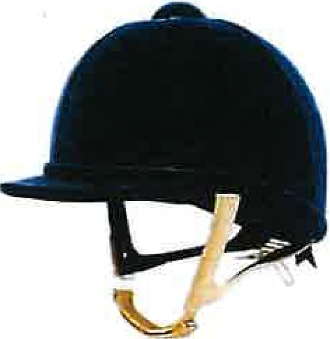

RING 2 WEDNESDAY 8.00am START
Prize Money: 1st $25, 2nd $15,3rd $10. Entry Fee $4.00 per entry.
No refunds on Entry Tickets.
COMPETITORS PLEASE NOTE: PONIES THAT HAVE COMPETED IN PONY
HACK CLASSES ARE NOT ELIGIBLE TO COMPETE IN PONY HUNTER HACK CLASSES
NO LEADING OF PONIES IN EITHER PONY HACK OR SHOW PONY HUNTER CLASSES, UNLESS STATED.

OPEN PONY HACK:
43. Pony Hack NOVICE, 12.2.hh. & under.
44. Pony Hack NOVICE, over l2.2hh n/e l4hh.
45. Pony Hack OPEN, 12hh & under.
46. Pony Hack OPEN, over 12hh n/e 13hh.
47. Pony Hack OPEN, over l3hh n/e 14hh.
48. Pony Hack for Mares, n/e 14hh.
49. Pony Hack for Geldings n/e 14hh.
49a. Pony Hack n/e 14hh. Child rider under 17 yrs.
Champion Pony Hack, Reserve Champion
50. Pair of Pony Hacks n/e 14hh.
51. Pony Hack Pleasure. (to be ridden in a snaffle)
52. Primary School Turnout. (to include Pony, Saddle, Bridle, School Bags Etc.)

SHOW HUNTER PONY
Prize Money-1st $25.00, 2nd $15.00,3rd $10.00. Entry Fee: $4.00 per entry.
53. Show Hunter Pony’ NOVICE, Ridden, 12.2hh & under.
54. Show Hunter Pony NOVICE, Ridden, over l 2.2hh n/e 14hh.
55. Show Hunter Pony OPEN l 2.2hh & under.
56. Show Hunter Pony OPEN over 12.2hh n/e 13.2hh.
56a. Show Hunter Pony OPEN over 13.2hh n/e 14hh.
57. Show Hunter Pony, n/e 14hh. Child rider under 17 years
57a. Show Hunter Pony for Mares n/e 14hh.
57b. Show Hunter Pony for Geldings n/e 14hh.

Champion Show Hunter Pony, Reserve Champion.
58. Show Hunter Pony, Lead Rein, (n/e 12hh) Juvenile Rider 3yrs & under 6 years.
59. Show Hunter Pony, Lead Rein (n/e 12hh) Juvenile Rider 6yrs & under 8 years.
Champion Show Hunter Lead Rein Pony, Reserve Champion

AUSTRALIAN SADDLE PONIES (RIDDEN)

60a Filly under 4 yrs n/e 14.2hh.
60. Mare 4 yrs & over 12.2hh & under
61. Mare 4 yrs & over 12.2hh n/e 13.2hh
62. Mare 4 yrs & over 13.2hh n/e 14.2hh
Champion Saddle Pony Mare, Reserve Champion
63. Gelding 12.2hh & under
64. Gelding 12.2hh n/e 13.2hh
65. Gelding 13.2hh n/e 14/4hh
Champion Saddle Pony Gelding, Reserve Champion
65a. Stallion n/e 14.2hh.
65b. Colt n/e 14.2hh.

ANY OTHER REGISTERED PONY BREED Ridden.
66. Stallion/Colt
67. Mare/Filly
Champion, Reserve Champion

WEDNESDAY CONT: RING 2
JUNIOR RIDERS:
Prize Money: 1st $15.00, 2nd $10.00, 3rd $5.00. Entry Fee $2.50 per entry.
No refunds if change of mind or unable to attend.
72. Lead Line Girl Rider Under 6 years.
73. Girl Rider 6yrs & under 8 yrs.
74. Girl Rider 8 yrs. & under 10 yrs.
75. Girl Rider 10 yrs. & under 12 yrs.

Champion Junior Girl Rider, Reserve Champion.
76. Lead Line Boy Rider Under 6 yrs.
77. Boy Rider 6yrs & under 8yrs.
78. Boy Rider 8yrs & under 10 yrs.
79. Boy Rider 10 yrs. & under 12 yrs.
Champion Junior Boy Rider, Reserve Champion.

(Junior/ Senior Champion Child Riders eligible for Supreme Child Rider.)

SENIOR BOY & GIRL RIDERS.
Prize Money: 1st $15.00, 2nd $10.00, 3rd. $5.00. Entry Fee: $2.50 per entry. No refund on Entry Tickets.
80. Girl Rider l2yrs & under 14yrs.
81. Girl Rider I 4yrs & under I 7yrs.

Champion Senior Girl Rider, Reserve Champion.
82. Boy Rider I 2yrs & under 14 yrs.
83. Boy Rider I 4yrs & under 17 yrs.

Champion Senior Boy Rider, Reserve Champion.

SUPREME CHILD RIDER OF THE SHOW. $30.00 & Sash
.
83a Quietest Childs Pony competing at the show. Any Rider 6 years & under 12 years.

PONY CLUB EVENTS
(The Ring will take a short break to allow competitors time to change costume for these events)

All riders must be financial members of a pony club, riders must ride in pony club uniform and riders must ride the same horse for all events.
Prize Money: 1st $15.00, 2nd $10.00, 3rd $5.00. Entry Fee $2.50per entry. No refunds if change of mind or unable to attend.

CLASES 084 – 086 Led Events, classes 087 – 094 ridden events.

84. Best Presented Pony Club Horse/Pony & handler under 12 yrs.
85. Best Presented Pony Club Horse/Pony & handler over 12 yrs. & under 17 yrs.
86. Best Presented Pony Club Horse & handler over 17 yrs.
Champion & Reserve Champion.
87. Pony Club Turnout boy or girl 6yrs & under 12 yrs.
88. Pony Club Turnout boy or girl I 2yrs & under I 7yrs.
89. Pony Club Turnout boy or girl 1 7yrs & over.
90. Best Pony Club Child Rider under 12yrs.
91. Best Pony Club Child Rider under 17yrs.
92. Best Pony Club Child Rider 17yrs. & Over.
Champion & Reserve Champion
93. Pair of Riders-6yrs & over.
94. Consolation Event. (No entry fee, ribbons only, event to be decided by the Steward.)

************************************************************************************

RING 1 THURSDAY 8.30AM START
Chief Steward: Mr. Simon Scadden.

ALL HORSES ENTERED IN LED CLASSES MUST BE REGISTERED WITH THEIR RESPECTIVE BREED SOCIETY. WHERE REQUIRED OWNERS MUST BE FINANCIAL MEMBERS. PAPERS/COPIES TO BE PRODUCED ON REQUEST.

LED IN CLASSES

Prize Money: - 1st $25.00 2nd $15.00 3rd $10.00 Entry Fee $4.00 per entry
Competitors please note: The change to ages of stallions/colts & mares/fillies.
COLT under 4year

- STALLION 4 years and over, (b). COLT under 4 years,
CHAMPION Stallion/Colt & Reserve
- MARE 4 years and over (d) FILLY under4 years, CHAMPION Mare/Filly &Reserve Champion (e)GELDING
(eligible for supreme gelding of show)

95a. Best Presented Handler & Led Exhibit ALL BREEDS. (Open to Stallions, Mares & Geldings.) Ring 1 Competitors only.
95. WARMBLOODS
96. OFF THE TRACK THOROUGHBREDS
97. THOROUGHBRED
98. ANSA
99. ANDALUSIANS-PUREBREEDS
100. ANDALUSIANS-PARTBRED
101. CLYDESDALES
101a. GYPSY COB
102. QUARTERHORSE,
102a. APPALOOSAS
103. PALIMINOS
104. ARABS (PUREBRED)
105. ARABS (DERIVATIVE)
106. PAINT HORSES
107. LED SHOW HUNTER GALLOWAYS.
-- 107a). Mares, 107b). Gelding. Champion & Reserve Champion
(Eligible Supreme Led Show Hunter of Show)
108. LED SHOW HUNTER HACKS.
-- 108a). Mares, 108b). Gelding. Champion & Reserve Champion
(Eligible Supreme Led Show Hunter of Show
109. LED GALLOWAYS
-- 109a). Mares, 109b). Geldings -Champ & Res. Eligible Supreme Led Hack of Show
110. LED HACKS
--110a). Mares, 110b) Geldings ---Champion & Res. Eligible Supreme Led Hack of Show
111. ANY OTHER REGISTERED BREED OVER 14 HANDS.

SUPREME LED EXIBIT OF THE SHOW (STALLION & MARES)-$150 +SASH SUPREME LED

SUPREME LED GELDING OF THE SHOW-$150+ SASH

SUPREME LED SHOW HUNTER EXHIBIT OF THE SHOW- $150 + SASH

SUPREME LED HACK OF SHOW - $150 + SASH.

BEST PRESENTED OTT MARE OR GELDING AND HANDLER

This event will be judged on conformation/behavior of Horse, suitability of costume & ability of handler for this event.

Prize Money: 1st $100, 2nd $75, 3rd $50. Entry Fee: $10.00

GENERAL RIDDEN CLASSES

Prize Money: 1st$25, 2nd $15, 3rd $10. Entry Fee: $4.00 per entry.
No refunds if change of mind or unable to attend.

COSTUME CLASSES- To be judged after Supreme Led events. Note: any riders under 6 years must be on a lead line.
For Safety reasons other riders in costume may be led.
Prize Money: 1st $100.00 2nd $50.00, 3rd $30.00. Entry Fee $10.00 per entry.
C1. Costume ADULT. Over 17 yrs.
C2. Costume CHILDREN under 17 years

COMPETET0RS-PLEASE NOTE: - HORSES COMPETING IN HACK CLASSES WILL NOT BE ELIGIBLE TO COMPETE IN HUNTER HACK CLASSES.

RIDDEN HACK/SHOWHUNTER CLASSES DISTRICT

PRIZE MONEY: 1st $25, 2nd $15, 3rd $10. Entry fee: $4.00 per entry per class.
No refunds of entry tickets.
For definition of District classes refer to section 14

112. District Hack Galloway MAIDEN over I4hh n/e15hh
113. District Hack Galloway NOVICE over 14hh n/e l 4.2hh
114. District Hack Galloway NOVICE over 1 4.2hh n/e 15hh
115. District Hack Galloway OPEN over 14hh & n/e 14.2hh
116. District Hack Galloway OPEN over 14.2hh n/e 15hh
117. District Hack Galloway CHILDREN'S (rider 6yrs & under 17yrs) over 14h & n/e 15hh
Champion District Galloway Hack & Reserve Champion
118. District Hack MAIDEN over 15hh
119. District Hack NOVICE over 15hh & n/e 15.2hh
120. District Hack NOVICE over 15.2hh & n/e 16hh
121. District Hack NOVICE over 16hh
122. District Hack OPEN over 15hh n/e 15.2hh
123. District Hack OPEN over 15.2hh n/e 16hh
124. District Hack OPEN over 16hh
125. District Hack CHILDREN'S (rider 6yrs & under l 7yrs)

CHAMPION DISTRICT HACK
RESERVE CHAMPION DISTRICT HACK

(Pony, Galloway & Hack eligible for Supreme Champion District Hack of Show)

SUPREME CHAMPION DISTRICT HACK OF SHOW (HACK, GALLOWAY, PONY) - $100.00
DISTRICT SHOW HUNTER GALLOWAY$ & HACKS.
126. District Show Hunter Galloway over 14hh & n/e l 4.2hh.
127. District Show Hunter Galloway over 14.2hh & n/e 15hh.
128. District Show Hunter Galloway n/e 15hh ridden by a child under 17ys
CHAMPION DISTRICT SHOW HUNTER GALLOWAY HACK &RESERVE CHAMPION.
129. District Show Hunter Hack over 15hh & n/e 15.2hh.
130. District Show Hunter Hack over 15.2hh & n/e I6hh.
131. District Show Hunter Hack over l 6hh.
132. District Show Hunter Hack over 15hh ridden by child under 17yrs.
CHAMPION SHOW HUNTER HACK & RESERVE CHAMPION.

(Show Hunter Pony, Galloway & Hack eligible for Supreme Champion District Show Hunter)

SUPREME CHAMPION DISTRICT SHOW HUNTER OF SHOW

(HACK, GALLOWAY, PONY) - $100.00

RING 2 THURSDAY START 8.30am
Chief Steward: - Linda Banks

RESPECTIVE BREED SOCIETY. WHERE REQUIRED OWNERS MUST BE FINANCIAL MEMBERS. PAPERS/COPIES TO BE PRODUCED ON REQUEST.

LED IN CLASSES- PONIES
Prize money- 1st $25.00, 2nd $15.00, 3rd $10.00.
Entry fee: - $4.00 per entry No refunds on Entry Tickets.

Competitors, please note change of ages stallion/colt, mare/filly under 4years.

All breeds will have classes a-e unless stated. All first place in Gelding classes eligible for Supreme Gelding Show.

(a) STALLION-4years & over

(b) COLT – under 4 years

Champion Stallion/Colt, Reserve Champion

(c) MARE – 4 years & over

(d) FILLY - under 4 years

Champion Mare/Filly, Reserve Champion

(e) GELDING any age.

133a Best presented Pony and Handler. (open to Stallions, Mares & Geldings)

133. AUSTRALIAN PONIES

134. APSB WELSH PONIES

135. APSB SHETLAND PONIES

136. APSB REGISTERED PART BRED

137. RIDING PONIES – 14.2hh & under.

138. MINITURE PONIES

139. MINITURE HORSE

140. WCPS WELSH PONIES

141. WCPS WELSH PONIES,

141a. WCPS PART BRED PONIES,

142. PONY HACKS. a). Mares, b). Gelding. Champ & Res. (Eligible Supreme Led Hack of Show).

143. AUSTRALIAN SADDLE PONY LED

a. Stallion 4yrs & over n/e 14.2hh.

b. Colt under 4 yrs, n/e 14.2hh.

CHAMPION LED SADDLE PONY STALLION/COLD, RESERVE CHAMPION.

c. Mare under 12.2hh.

c1 Mare over 12.2hh n/e 13.2hh

c2 Mare over 13.2hh n/e 14.2hh

c4 Filly under 4 years, under 14.2hh

CHAMPION LED SADDLE PONY MARE/FILLY, RESERVE CHAMPION MARE/FILLY.

d. Gelding under 12.2hh

d1 Gelding over 12.2hh & n/e 13.2hh

d2 Gelding over 13.2hh & n/e 14.2hh.

CHAMPION LED SADDLE PONY GELDING & RESERVE CHAMPION GLEDING.
(Eligible for Supreme Led Exhibit of show/Geld.)

SHOW HUNTER PONY
143a. Led Show Hunter Pony Mare n/e 12.2hh
143b. Led Show Hunter Pony Mare over 12.2hh n/e 14hh
143c. Led Show Hunter Pony Gelding n/e 12.2hh
143d. Led Show Hunter Pony Gelding over 12.2hh n/e 14hh
Champion, Reserve Champion. (Eligible Supreme led S/Hunter)

KEITH BURNS MEMORIAL GRAND CHAMPION PONY OF SHOW: $100 + Sash.

144. UNREGISTERED CLASSES: Horses & Ponies together (must not hold Registration or

Classification papers.)

a. Mare/Filly b. Gelding.

THURSDAY CONTINUED. RING 2.

RIDDEN PONY EVENTS:

Prize Money: 1st $25, 2nd $15, 3rd 10. Entry Fee: $4.oo per entry per event.

No Refunds if change of mind or unable to attend.

AUSTRALIAN SADDLE PONY – RIDDEN

145. Ridden Gelding, 12.2hh & under

146. Ridden Gelding, over 12.2hh n/e 13.2hh

147. Ridden Gelding, over 13.2hh n/e 14.2hh. Champion ASP Geld, Reserve Champion.

148. Ridden Mare, 12.2hh & under

149. Ridden Mare, over 12.2hh n/e 13.2hh

150. Ridden Mare, over 13.2hh n/e 14.2hh. Champion ASP Mare, Reserve Champion.

151. Ridden Stallion, n/e 14.2hh. Champion ASP Stallion, Res Champion.

RIDING PONIES – RIDDEN

152. Ridden Gelding, 12.2hh & under

153. Ridden Gelding, over 12.2hh n/e 13.2hh

154. Ridden Gelding, over13.2hh n/e 14.2hh

155. Ridden Mare, 12.2hh & under

156. Ridden Mare, over 12.2hh n/e 13.2hh

157. Ridden Mare, over13.2hh n/e 14.2hh.

158. Ridden Stallion, n/e 14.2hh.

Champion Ridden Riding Pony, Reserve Champion.

Competitors note ponies competing in pony hack classes CANNOT compete in Hunter Pony Classes.

DISTRICT PONY HACKS

159. District Pony Hack, Maiden n/e 14h

160. District Pony Hack, Novice, 12.2hh & under

161. District Pony Hack, Novice, over 12.2hh n/e 14hh

162. District Pony Hack, Open, 12.2hh & under

163. District Pony Hack, Open over 12.2hh n/e 14hh

Champion District Pony Hack, Reserve Champion.

(Champion District Pony Hack is eligible for Supreme District Hack of Show)

DISTRICT SHOW HUNTER PONY – RIDDEN

164. District Show Hunter Pony Maiden, n/e 14hh.

164a District Show Hunter Pony, Novice, n/e 14hh.

164 District Show Hunter Pony-OPEN, 12.2hh & under

165. District Show Hunter Pony-OPEN, over 12.2hh n/e 13hh

165a District Show Hunter Pony- OPEN, over 13.2hh n/e 14hh

Champion District Show Hunter Pony, Reserve Champion.

(Champion District Show Hunter Pony is eligible for Supreme District Show Hunter of Show)

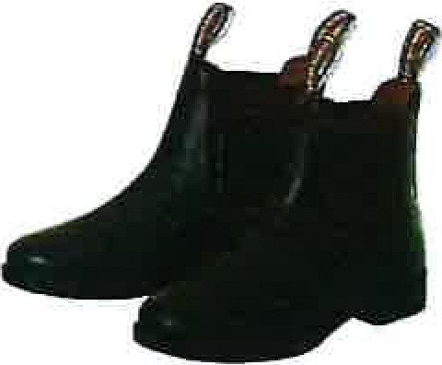

RING 3 WEDNESDAY 28 May 2025 8AM START.

TO BE HELD IN UNDERCOVER ARENA. (WEDNESDAY ONLY)

AUSTRALIAN STOCK HORSES

ALL HORSES ENTERED IN LED AND RIDDEN BREED CLASSES MUST BE REGISTERED WITH THEIR RESPECTIVE BREED SOCIETY. WHERE REQUIRED OWNERS MUST BE FINANCIAL MEMBERS. PAPERS/COPIES TO BE PRODUCED ON REQUEST.

Working Classes
Prize money: 1st $25, 2nd $15, 3rd $10. Entry Fee: $4.
- Ridden 4years and under Colt Working
- Ridden 4years and under Mare Working
- Ridden 4years and under Gelding Working
Champion and Reserve Champion, 4 year and under

- Ridden Stallion 5 years and over, not exceeding 15 hands
- Ridden Stallion 5 years and over, over 15 hands
Champion and Reserve Champion, Working Stallion

- Ridden Mare 5 years and over, not exceeding 15 hands
- Ridden Mare 5 years and over, over 15 hands
Champion and Reserve Champion, Working Mare

- Ridden Gelding 5 years and over, not exceeding 15 hands
- Ridden Gelding 5 years and over, over 15 hands
Champion and Reserve Champion, Working Gelding

- Ridden Mare any age ridden by a Child (17&under)
- Ridden Gelding any age ridden by a Child (17&under)
Champion and Reserve Champion, Childs working Stockhorse

STOCKMENS CHALLENGE.

Open to all breeds registered or unregistered.

Class:

Sheady Aust Stockhorses - Junior Horse Challenge – 4yrs & under.

Dry work pattern – WP1

Utility pattern – UP1

Overall

Prize Money sponsored by Sheady Aust Stockhorses, Biggenden.

1st $75,2nd$50,3rd$40,4th$30,5th$20. Entry Fee: $4.

Proudly sponsored by Sheady Aust Stockhorses.

Oceanview Stock Horses - Open Horse Challenge – 5yrs & over.
Dry work pattern -WP12
Utility pattern - UP1
Overall
Prize Money
1st $25, 2nd $15, 3rd $10. Entry Fee: $4

- Juvenile Challenge (Rider 13-16 Yrs)
Dry work pattern WP1
Utility Pattern – UP1
Overall
Prize Money: Entry Fee: $4
1st $25, 2nd$15,3rd $10.

- Junior Challenge (Rider aged 8-12 Yrs)
Dry work pattern WP1
Utility Pattern – UP1
Overall
Prize Money
1st $25, 2nd $15, 3rd$10. Entry Fee: $4.

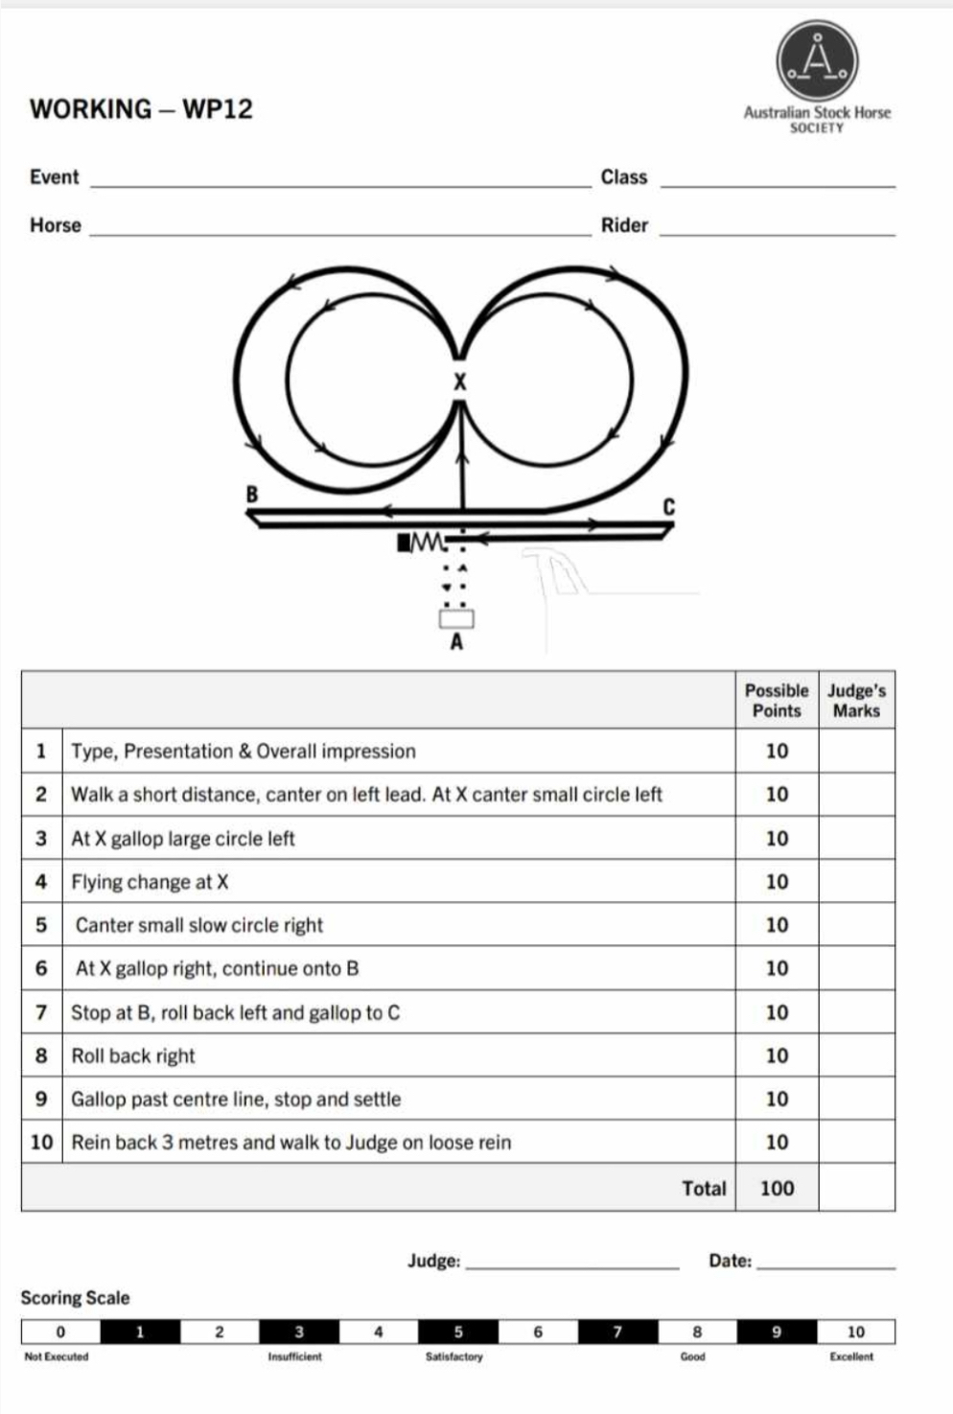

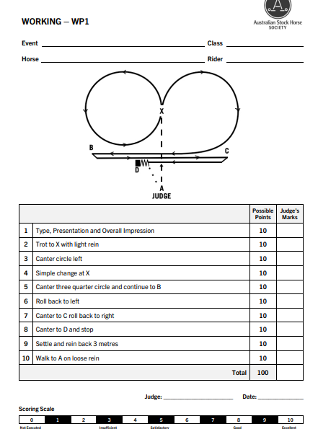

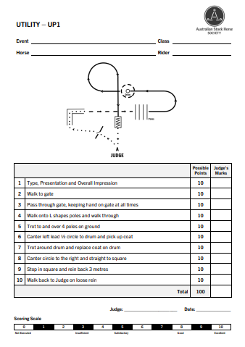

RING 3 THURSDAY- 29 MAY 2025 MAIN ARENA 8.30 START

AUSTRALIAN STOCK HORSE.

ALL HORSES ENTERED IN LED AND RIDDEN BREED CLASSES MUST BE REGISTERED WITH THEIR RESPECTIVE BREED SOCIETY. WHERE REQUIRED OWNERS MUST BE FINANCIAL MEMBERS. PAPERS/COPIES TO BE PRODUCED ON REQUEST.
LED Classes
Prize Money: 1st $25, 2nd $15, 3rd $10. Entry Fee: $4.00
- Colt 4 years & under.
- Filly 4 years & under.
Champion and Reserve Champion.
- Gelding 4 years & under.

- Led Stallion 5 years and over.
Champion and Reserve Champion.

- Led mare 5 years and over, not exceeding 15hands.
- Led mare 5years and over, 15 hands and over.
Champion and Reserve Champion.

- Led gelding 5 years and over, not exceeding 15hands.
- Led gelding 5years and over, 15 hands and over.
Champion and reserve Champion. (Winner of Class 3 eligible for Champion Gelding.)

The David Whalley Memorial Supreme Led Australian Stockhorse
(All Champion led ASH eligible for Supreme led exhibit of show & all first place Geldings are eligible for Supreme led Gelding of Show)
Ridden Australian Stock Horse Hacks
Prize money: 1st $25, 2nd $15, 3rd $10. Entry Fee $4.
Classes
- Ridden ASH Filly hack 4 years & under.
- Ridden ASH Colt hack 4 years & under.
Champion and Reserve Champion.
- Ridden ASH Gelding hack 4 years & under.
Champion & Reserve Champion 4 yrs & under. Ridden ASH.
- Ridden ASH Stallion hack 5years and over.
Champion and Reserve Champion.
- Ridden ASH Gelding hack 5 years and over, n/e 15hh
- Ridden ASH Gelding hack 5 years & over,15hh. & over.
Champion and Reserve Champion. (Classes 11, 13 & 14 eligible)
- Ridden ASH Mare 5 years and over, n/e 15hh.
- Ridden ASH Mare 5 years and over, 15hh & over.
Champion and Reserve Champion.
- ASH hack ridden by a Lady.
- ASH hack ridden by a Gentleman.
- ASH hack ridden by a Child.
Champion and Reserve Champion.
Supreme Ridden ASH Hack (Champions from classes 9-19 eligible)
Sash & $100 prize money.

THE LEISA WHALLEY MEMORIAL HIGH POINTS AUSTRALIAN STOCK HORSE EXHIBIT. (Calculated throughout the two days of the Show)

QUEENSLAND CHAMBER OF AGRICULTURAL SOCIETIES INC
THIS DOCUMENT IS A NO DUTY OF CARE RISK WARNING. THIS DOCUMENT IS A WAIVER OF DUTY OF CARE

NEW INDEMNITY FORM
BUNDABERG A P & I SOCIETY INC. BUNDABERG SHOW

EventDate.........................................................
Participant Name: ...........................................................................................Participant Date of Birth: .........................
Participant Address: ..............................................................................................Suburb....................................................
Participant Contact Number: ...............................................................................................................................................
Participant Email: ....................................................................................................................................................................

Section A - Supplier's statements about risk and duty of care
Queensland Chamber of Agricultural Societies Inc and BUNDABERG SHOW (together the Suppliers) advise
as set out below.
The handling of animals is a dangerous recreational activity as animals can act in a sudden and unpredictable way, especially when frightened or hurt.
Participation (including passive participation) in animal handling and/or physical competitions and/or Events at an agricultural show and/or use of the Suppliers' facilities contain elements of risk, both obvious and inherent.
Physical competitions and activities, Events and use of the Suppliers' facilities are all dangerous recreational activities.
This document is a risk warning for the purpose of the Civil Liability Act (2003) QLD and Australian Consumer Law. Any and all warranties, conditions and guarantees in relation to the competitions and activities, Events and use of Suppliers' facilities which are implied by Australian Consumer Law are excluded to the fullest extent permitted by law.
This risk warning is given by or on behalf of the Suppliers.
This document acts as an exclusion of liability under the Civil Liability Act (2003) QLD if the services supplied by the Suppliers are supplied without reasonable care and skill.
Section B - Participant's acknowledgements
By signing this document, I acknowledge that:
Participation in the Event and/or use of the Suppliers' facilities is a recreational activity for the purpose of the Civil Liability Act (2003) QLD and Australian Consumer Law
- I participate in the Event and/or use of the Suppliers' facilities at my own risk.
- Participation in the Event and/or use of the Suppliers' facilities is a hazardous activity and involves a significant risk of physical harm and may result in injury, loss, damage or death to me and others.
- Participation in the Event and/or use of the Suppliers' facilities requires certain skills and experience. declare that I have sufficient skills and experience to be able to safely and properly participate in the event and/or use the Suppliers' facilities.
- Animals can act in sudden and unpredictable ways, especially if frightened or hurt, or if exposed to loud or unfamiliar noises.
- The Event will be held in close proximity to rides and large groups of people and there may be loud and unfamiliar noises which can frighten animals used in the Event.
- If the Event is held outdoors, there are risks to me as a result of the weather conditions, including either extreme hot or cold weather, rain, or wind.
- Insects or other animals may cause animals used in the Event to become frightened and act in an unpredictable way.
In handling animals, there is a risk of suffering injury including injuries caused by the animals.

- I am responsible for ensuring that I have and will wear equipment suitable for my safety in my participation of the Event and/or in using the Suppliers' facilities.
- I am responsible for the condition of any tools and equipment and ensuring that they are appropriate for the Event and/or in using the Suppliers' facilities.

- I use the Suppliers' facilities, including for the Event entirely at my own risk, as I find them and with the prior acceptance of the risk of possible danger to me, both obvious and inherent.
- At the time of participating in the Event and/or in using the Suppliers' facilities, I will not to any degree be under the influence of alcohol or illicit drugs.

- I will not consume any alcohol or illicit drugs while participating in the Event and/or in using the Suppliers' facilities and agree that such use may result in my being excluded from the Event and/or from using the Suppliers' facilities with no entitlement to any refund of money paid to the Suppliers for entry.
- I agree to be bound by the rules and guidelines of the Suppliers as varied from time to time.
Section C - Participant's acceptance of risk & no duty of care & waiver of rights
- I acknowledge and agree that my participation in the Event and any associated activities and/or my use of the Supplier's facilities is dangerous and may have obvious and/or inherent risks as a result of which personal injury (and sometimes death) may occur.
- I acknowledge that my participation in the Event and any associated activities and/or my use of the Supplier's facilities carry with them a significant risk of physical harm.
- I accept and assume all risks of personal injury or death in anyway whatsoever arising from my participation in the Event and any associated activities and/or my use of the Supplier's facilities.
- I waive my individual right to sue the Suppliers for all claims I may have for such personal injury or
death against the Suppliers in any way whatsoever arising from or in connection with my participation in the Event and any associated activities and/or my use of the Supplier's facilities.
- If I suffer personal injury or death while participating in the Event and/or from my use of the Supplier's facilities, I will not hold the Suppliers, their employees, or agents legally responsible for any personal injury
or death I suffer.
- I will not sue the Suppliers, their employees or agents 'for any claims, actions, costs, damages, or liability.
- I release the Suppliers and their employees from legal responsibility for the services I have been provided and/or activity I have participated in, including the Event.
Section D - Signature (Please ignore and sign at Section F if using a Bulk Waiver) Where the participant is 18 years of age or over:
I agree that I have read and understood this waiver prior to signing it.
I acknowledge that the Suppliers have permitted me to participate in the activity the subject of this document in reliance on the matters acknowledged by me and the representations I have made in this document.
I agree that this waiver is governed in all respects by and interpreted in accordance with the laws of Queensland and Commonwealth of Australia where applicable.
I agree that everything in this document is binding on me and my heirs, next of kin, executors, and administrators. Signature: ....................................................................................................Date..................................................................
Where participant is UNDER 18 years of age (to be completed by a parent or guardian):
Participant Date of Birth: ....................................................................................................................................................
l (lnsert parent/guardian name)
being a parent or legal guardian of the above-named participant, hereby consent to my child using the Suppliers' facilities and/or participating in the Event.
I confirm that I have read and understood and explained to the participant this waiver prior to signing it.
I acknowledge that the Suppliers have permitted the participant to participate in the activity the subject of this document in reliance on the matters acknowledged by me and the representations that I have made in this document.
I agree that this waiver is governed in all respects by and interpreted in accordance with the laws of Queensland and Commonwealth of Australia where applicable.
I agree that everything in this document is binding on me and my heirs, next of kin, executors, and administrators. Signature: ...................................................................................................Date...................................................................

Bundaberg A. P. & I. Society Inc.
Bundaberg Show
Section E - Horse Details and Acknowledgement
1/there are horses in this event then this Section MUST BE COMPLETED
Name of Horse | Owner's Name | Microchip/Reg#  or Description (Sex, Color,  Brand) | PicNo. | Last Event & Date | Signature | Date

I, the owner/rider/exhibitor of the above horse, declare that, to the best of my knowledge, it is fit and healthy and I agree that if found to be otherwise, it will not be allowed to compete at this event. If prior to the event, the health of the horse changes from the date of this declaration, I will inform the event organizer for their due consideration.

………………………………Signature …………….date
Bundaberg A. P. & I. Society Inc.

Bundaberg Show
Section F- Bulk Signature Facility (if required)
- I ACKNOWLEDGE THAT I HAVE READ AND UNDERSTOOD the above SECTIONS A through to D WARNING ME OF THE RISKS OF MY PARTICIPATION IN THE ACTIVITY
- I HAVE MADE ALL FURTHER ENQUIRIES WHICH I FEEL ARE NECESSARY OR DESIRABLE AND FULLY UNDERSTAND THE RISKS INVOLVED IN THIS ACTIVITY
I SIGN THE DOCUMENT FREELY AND VOLUNTARILY WITHOUT ANY INDUCEMENT MADE TOME
PARTICIPANTS  NAME  (Please Print) | PARTICIPANT  or PARENT/GUARDIAN'S SIGNATURE | ADDRESS | EMAIL ADDRESS | DATE OF BIRTH | CONTACT NUMBER

I. ....................................................... have observed the sighting and signing of this document by the
(PLEASE PRINT)

Signature of Responsible Official/Witness Date:

STABLES AND CAMPING BOOKING FORM
HORSE STABLES & CAMPING MUST BE BOOKED & PAID FOR BY WED21nd Mav 2025. THERE WILL BE NO REFUND OF STABLE/CAMPING FEE AFTER 23rd Mav 2025.
Limited number of Stables/Camp sited. Book/Pay ASAP to secure your stables/camp.
Enquiries to Maree See Ph 0427 266 326

PLEASE COMPLETE FORM AND RETURN TO: Bundaberg Show Society office, ,Bundaberg Recreational Precinct, or email secretary@bundabergshow.com.au
NO ELECTRIC FENCES/TEMPORY YARD PERMITED IN THIS SECTION

STABLES BOOKING

$40.00 per stable/portable yard- ALL STABLES MUST BE LEFT CLEAN/STRINGY HAY/MANURE.
Name of competitor ..........................................................................................................
Address/email ...................................................................................................... Phone No......................
No. of stables required: No. for stallions ......... Height of each stallion .....................................

No. for geldings ......... Height of each gelding .....................................

No. for mares ............ Height of each mare........................................

Please indicate: Showjumpers/ Hacks/ Led/ Sporting/ Team Penning/ Pony Club
Please indicate nights required: Sun.25th, Mon.26th \ Tues 27th \ Wed. 28th \ Thurs. 29th & Fri 30st May.
Payment enclosed $......................
PLEASE NOTE: The number of stables is limited. Stables will be allocated only when the bookings AND fees are received.
._ .,

Banking Details - Bunda berg AP & I Society BSB 633-000 Ale No: 164 779 225
Please email a copy. with your name, of the bank receipts for our record.

CAMPING BOOKING
Camping fee $40.00 per site (1 vehicle only)
CAMPING IS AVAILABLE FOR A FEE OF $40.00 PER SITE FOR PERIOD OF SHOW FROM SUNDAY 25th MAY 2025 TO SAT, 31st 2025. ALL VEHICLES/HORSES MUST LEAVE PRECINCT BY 12 MIDDAY 31st May.
Name of site occupant .......................................................... Phone No..............................
Address /email........................................................................No. of Sites required .............

Length of Unit: Semi- .......... mt/ Body truck-........ mt/ Gooseneck- mt/

Width of Unit: …….. ……… ……….. (pullouts etc.)
Other (please describe mt
Payment enclosed $....................................

BOOK CAMPSITE EARLY. LIMITED SEMI/LONG G. NECK SITES AVAILABLE.

ALL CAMPSITES WILL BE NUMBER ALLOCATED.

