2021

127th

BUNDABERG REGIONAL SHOW

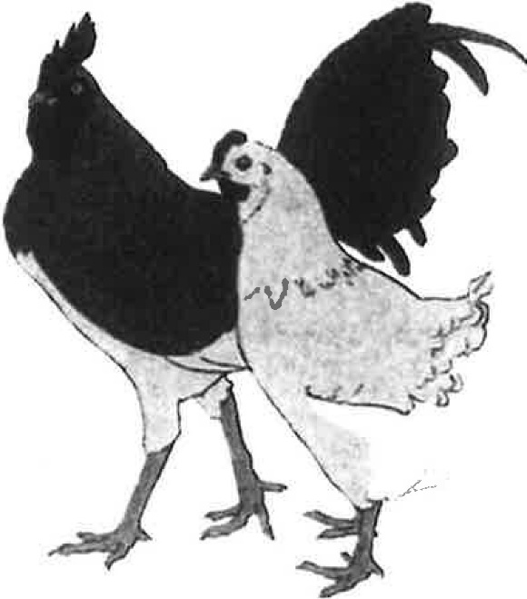
\
. ,-
/
.-
--,.1
I\
/
!

WEDNESDAY 26th May THURSDAY 27th May
FRIDAY 28th May POULTRY

ALL ENTRIES WILL BE BY EMAIL (DIRECT DEPOSIT) OR AT THE SHOW OFFICE (EFTPOS) ENTRIES CLOSE 22 !\,IA Y 2021.

THE BUNDABERG SHOW WILL COMPLY WITH THE QLD AGRICULTURAL SHOWS & SHOWGROUNDS INDUSTRY COVIDSAFE PLAN

PRIVACY STATEMENT

The information provided by Exhibitors is used by the Queensland Chamber of Agriculture Associations Inc. and the Bundaberg A.P. & I. Society Inc. to organize, process and conduct competitions at the Bundaberg A P & I Society Inc show. By entering such competitions you consent to your personal information being used for this purpose including this information being made available to sponsors, breed Associations, the media, the public, promotional purposes, archival purposes, published in publications or as it is otherwise required by Law.
All exhibitors have the right to access and alter personal information concerning themselves in the terms of the Privacy Act. This can be done by contacting the QCAS CEO or by writing to QCAS.

WORICPlACE HEALTH ANO SAFETY

All Queensland Chamber of Agriculture Societies Inc. affiliated Association Showgrounds are designated workplaces within the meaning of the
Workplace Health and Safety Act 2011 and exhibitors/competitors are required to ensure that they and all persons under their direction or control, including their contractors or subcontractors, comply with all requirements of the Act. The Queensland Chamber of Agriculture Associations Inc hold each exhibitor responsible to discharge its obligations to provide and maintain a safe place and system of work during occupation by the exhibitor/competitorof any area of the affiliated Agricultural Associations Showgrounds/Precincts.

Each exhibitor/competitor will assess the risk to themselves, staff, volunteers, family, other exhibitors, Agricultural Society staff, show visit ors, children and any person foreseeably affected by the presentation of their exhibit.

Exhibits will only be held and handled by competent persons whose experience is known to the Exhibitor/competitor .

The exhibitors/competitors are advised that the use of Primus Stoves, any heating or lighting appliances of a like character, or any naked light, is strictly prohibited in Pavilions/stables/barns.
Any exhibitors/competitors intending to bring electrical equipment to the Showgrounds/Precinct will be required to ensure that such equipment is fitted with a residual current protection and that all electrical leads, tools and appliances have been inspected by a licensed electrical contractor and are currently tagged. The use of double adaptors is prohibited and all power boards must also be tested and tagged.

All exhibitors/competitors will comply with the requirements of the ACT and its Regulations and Standards in every respect. This is essential for the safety of all exhibitors/competitors and the general public. The ACT imposes very severe penalties in the event of noncompliance with its provisions. Any exhibitors/competitors who do not comply will not be allowed to exhibit at "Queensland Chamber of Agriculture Association Inc. affiliated Shows".

The Bundaberg A.P. & I. Society Inc. is manned by a wonderful group of volunteers. They work tirelessly to prepare, present and provide an Annual Bundaberg Show solely for the benefit of the people of the Bundaberg Region. We could not operate and provide this event without the help of our volunteer Committee members & workers that set up, pull down, maintain all equipment, operate the forklifts and include our hardworking show stewards.

The whole purpose of our Bundaberg Show is to provide a platform to display, show and inform the members of our community and visitors to our Region of the Agricultural achievements in our region and the many Pastoral businesses and services available, as well as the Industrial business and services available. We exhibit a high quality the regions breeding within Horses, Cattle & Poultry, as well as our outstanding Art and Craft talents to our visitors. Would you like to volunteer?

We wish you a safe pleasant visit to YOUR SHOW.
'

HOW TO ENTER THE SECTIONS

FILL OUT ENTRY FORMS

All entries must be:
On Official Entry Forms

On SEPARATE Entry Forms for Each Section (NOT CLASS) Fully completed
Accompanied by Entry Fees (Refer Sections)

ENTRIES WILL NOT BE ACCEPTED
Without entry fees Over the telephone After closing date

DELIVER ENTRY FORMS TO
Bu ndabergShowSocietyOffice viaUniversityDrive,Bundaberg Enquiries - Phone 07 4155 0802

Delivery of entry forms - Mon-Fri from 9am-4pm 1 May-21 May 21 YOU WILL RECEIVE : Receipt.
DELIVER EXHIBITS: CJ MCieiian Shed. befon1 7pm Tun 25.521.

Accompanied by Class Ticket (ATTACHED) (if applicable) (This is proof of Entry in a Class)
To designated part of Showground by due date and time.

PLEASE REFER TO RULES FOR EACH SECTION FOR CLOSING

Prize money: All prize money is to be collected at the Show Office from 1pm Wednesday 26th May 21 to 2pm Saturday, 29th May 2021.
PRIZE MONEY NOT COLLECTED BY 2PM, SATURDAY, 29TH MAY 2021 WILL BE FORFEITED & RETURNED TO SOCIETY'S FUNDS.

ALL ENTRY FEES AND PRIZE MONEY INCLUDE GST WHICH IS PAYABLE BY ALL COMPETITORS WHETHER REGISTERED OR NOT FOR GST PURPOSES.

Keep COVIDSAFE - Maintain 1.5m between alt people.

DO NOT SHARE EQUIPMENT.
Your anawen, to the below quBStlon• will detarmlne If you .,. permitted entrllnce
to the Bundabsrg A.P. & I. Society Inc. Bundaberg Show 2021.

In the last 2 weeks have you had COVID-19 symptoms?
- Do you agree to follow Bundaberg A.P& I. Society Inc. COVID-19 precautions to help prevent the spread of COVID-19 ?

Have you had close contact with anyone with a confirmed or probable case of COVID-19?
- Is it busine$s-critical that you come on-site or can you conctuct your work virtually?
IF THE ANSWER TO ANY OF THE ABOVE QUESTIONS IS YES. DO NOT ENTER THE BUNDABERG RECREATIONAL PRECINCT.

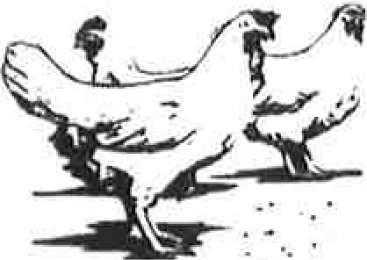

Section 5
POULTRY

CONDITIONS OF ENTRY

. Late entries or substitute birds will not be accepted.
. There will be no limit of entries.
. No exhibit ca·n be entered in more than one class.
Any bird dyed or in any way interfered with will be disqualified and the exhibitor dealt with as the Committee may think fit.
. Any person found removing eggs from the coops in the show shall be prosecuted. All eggs are the property of the Show Society.
. Should any dispute arise for which no specific rule is laid down. the matter will be referred to the Committee, whose decision shall be final
. Weight of pit game to be the responsibility of the exhibitor. Exhibits must be presented clean, free of disease and vermin.
. Alf exhibits must be the bona fide property of the exhibitor at the time of entry.
. Exhibits will be fed by the Society, without charge to the exhibitor.
. Judging will be open to the public.
Young bird's category - cockerel & pullet (no older than 12 months) will be up to the decision of the judge
. For delivery of exhibits and collection of same, entry to the grounds may be gained through the Kendalls Road Gate, where a list of all bona fide exhibitors will be kept. Only persons on this list will be admitted.
Sale of poultry at the Show will include (10% of price paid to the Show Society). No attendants' passes will be issued on this section.
. ENTRIES CLOSE FRIDAY 21st May at 4 00 pm
. Exhibits to be delivered to Poultry Pavilion Tuesday 25th May between 2.00 pm & 8.00 pm.
. Exhibits to be collected on Friday 2stn May between 2.30pm & 5.00pm. Refer to Chief Steward for collection details.
Prize money to be collected from Show Office on 1pmWednesday 26th May and Saturday 29th May (until 2pm). Refer to Chief Steward for collection details. Prize money not collected by 2pm on
29.5.21 will be forfieted and returned to Society's funds.

CHIEF STEWARD Mal McDougal 0412 797 892 41551094
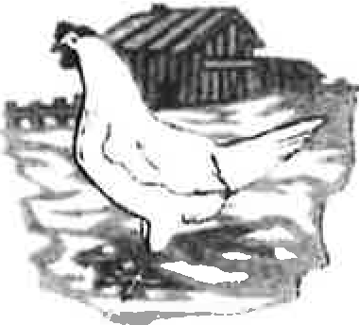
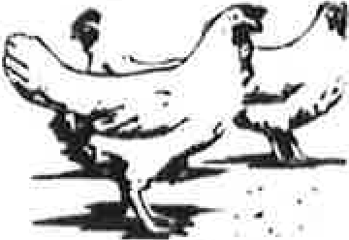

ENTRY FEES $2 00 per entry

PRIZEMONEY
1st $5.00,
2nd $3.00,
3rd $2.00
1
Prize money will be paid according to the number of exhibits and not entries in each class.
ANY SECTION UNDER 50 ENTRIES WILL BE JUDGED MALE, FEMALE & CHAMPION ONLY.

HARDFEATHER LARGE FOWL

OLD ENGLISH GAME
5/1 BLACK RED
5/2 DUCKWING A.C.
5/3 BLUE RED
5/4 PILE
5/5 BROWN RED
5/6 A.O.C. (State Colour)
5/7 INDIAN GAME
5/8 HEAVY PIT GAME
Males over 2.5kg, females over 2kg
5/9 LIGHT PIT GAME
Males under 2.5kg, females under 2kg
5/10 A.O.V. (State variety)

SOFTFEATHER LARGE FOWL
5/11 AUSTRALORP
5/12 WHITE WYANDOTTE
5/13 CHINESE LANGSHAN
5/14 RHODE ISLAND RED
5/15 LIGHT SUSSEX
5/16 HAMPSHIRE - NEW
5/17 BUFF ORPINGTON
5/18 PLYMOUTH ROCK
5/19 WHITE LEGHORN
5/20 LEGHORN A.O.C
5/21 MINORCA
5/22 ANCONAS
5/23 SILKIES
5/24 A.O.V.

HARDFEATHER BANTAM

MODERN GAME
5/25 BLACK RED
5/26 BLUE RED
5/27 DUCKWING
5/28 PILE
5/29 A.O.C. (State colour)

OLD ENGLISH GAME
5/30 BLACK RED
5/31 PARTRIDGE UL
5"32 PARTRIDGE D/L
5/33 WHEATEN
5/34 SPANGLED
5/35 DUCKWING AC
5/36 BLUE RED
5/37 BLUETAIL WHEATEN
5/38 PILE
5/39 A.O.C. (State colour)
5/40 INDIAN GAME
5/41 JUBILEE GAME
5/42 PIT GAME
5/43 A.O.V.

SOFTFEATHER BANTAM
5/44 BLACK ROSECOMB
5/45 AUSTRALORP
5/46 WHITE PEKIN
5/47 BLACK PEKIN
5/48 PEKIN A.O.C.
5/49 WHITE WYANDOTTE
5/50 WHITE LEGHORN
5/51 LEGHORN A.O.C.
5/52 RHODE ISLAND RED
5/53 LANGSHAN
5/54 LANGSHAN AOC
5/55 SUSSEX
5/56 ANCONAS
5/57 A.0.V.
5/58 SEABRIGHT (A.O.C )

WATERFOWL DUCKS
5/59 MUSCOVY
5/60 ROUEN
5/61 INDIAN RUNNER
5/62 KHAKI CAMPBELL
5/63 MALLARD- NATURAL
5/64 MALLARD - WHITE
5/65 PEKIN
5/66 CRESTED
5/67 CAYUGA
5/68 SILVER APPLEYARD
5/69 A.O.V. (State breed)
5/70 GEESE
5/71 TURKEYS
5/72 GUINEA FOWLS

EXHIBITION PAIRS
5/73 HARDFEATHER LARGE
5/74 SOFTFEATHER LARGE
5/75 HARDFEATHER BANTAM
5/76 SOFTFEATHER BANTAM
5/77 WATERFOWL
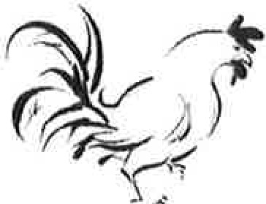

PAIR OF PULLETS OR FEMALES
5/78 HARDFEATHER LARGE
5/79 SOFTFEATHER LARGE
5/80 HARDFEATHER - BANTAM
5/81 SOFTFEATHER- BANTAM
5/100 PAIR OF FEMALES WATERFOWL
5/101 PET CLASS

RIBBONS CHAMPION BIRD OF SHOW RESERVE BIRD OF SHOW
CHAMPION SOFTFEATHER LARGE FOWL
CHAMPION HARDFEATHER LARGE FOWL CHAMPION HARDFEATHER BANTAM CHAMPION SOFTFEATHER BANTAM CHAMPION WATERFOWL
CHAMPION BREEDING PAIR
CHAMPION MALE HARDFEATHER LARGE FOWL

RESERVE CHAMPION MALE HARDFEATHER LARGE FOWL

CHAMPION MALE SOFTFEATHER LARGE FOWL

RESERVE MALE SOFTFEATHER LARGE FOWL CHAMPION MALE HARDFEATHER BANTAM RESERVE MALE HARDFEATHER BANTAM CHAMPION MALE, SOFTFEATHER BANTAM RESERVE MALE SOFTFEATHER BANTAM
CHAMPION FEMALE HARDFEATHER LARGE FOWL

RESERVE FEMALE HARDFEATHER LARGE FOWL

CHAMPION FEMALE SOFTFEATHER LARGE FOWL

RESERVE FEMALE SOFTFEATHER LARGE FOWL

CHAMPION FEMALE HARDFEATHER BANTAM RESERVE FEMALE HARDFEATHER BANTAM CHAMPION FEMALE SOFTFEATHER BANTAM RESERVE FEMALE SOFTFEATHER BANTAM CHAMPION EXHIBITION PAIR,
RESERVE EXHBITION PAIR

CHAMPION PAIR OF FEMALES RESERVE PAIR OF FEMALES CHAMPION MALE WATERFOWL RESERVE MALE WATERFOWL
GRAND CHAMPION BIRD OF THE SHOW RESERVE CHAMPION BIRD OF THE SHOW

CHAMPION BIRD OF THE SHOW $75.00
RES CHAMPION BIRD OF SHOW $25.00 CHAMPION EXHIBITION PAIR OF SHOW $15.00 CHAMPION HARDFEATHER • LARGE FOWL $15.00 CHAMPION SOFTFEATHER - LARGE FOWL $15.00 CHAMPION HARDFEATHER BANTAM $15.00 CHAMPION SOFTFEATHER BANTAM $15.00 CHAMPION PAIR OF PULLETS $15.00
CHAMPION WATERFOWL $15.00

CHAMPION MALE, RESERVE CHAMPION MALE, CHAMPION FEMALE, RESERVE CHAMPION FEMALE
$10.00

The Society wishes to thank -

BUNDABERG POULTRY FANCIERS CLUB,
BOYLANS PRODUCE for their donations to the
Poultry Section.

PLEASE NOTE:
The Society wishes to advise that NO PEAFOWL ENTRIES will be accepted, as the pens are not large enough to accommodate same.

POULTRY ENTRY FORM

EACH £>..H!BITOR TO BE O.V A SEPARATE FORM
PLEASE NOTE: MULTCPLE ENTRIES PER SECTION TO BE WRITTEN ON THE ONE FORM. YOU DO NOT NEED TO COMPLETE A SEPARATE ENTRY FORM PER CLASS IN ANY PARTICULAR SECTION.
To the Secretary: Subject to the Rules, By-Laws and Regulations of your Society and the Queensland Chamber of Agricultural Societies, I make the following entries for your forthcoming Show.
EACH SECTION NOT CLASS TO BE ON A SEPARATE FORM ONE LINE PER ENTRY
PLEASE PRINT
NAME OF
EXHIBITOR - - - - - - -

ADDRESS

PHONE NUMBER - - - - -

FCAQ CERTIFICATE NO:
EMA IL : _

SECTION l BREED & COLOUR |  | COCK | HEN | CKL | PULLET | EXHIB PAIR | PAIR FEMALES
 |  |  |  | --
 |  |  | ·--
 |  |  | · ·
I
 |  |  |  | --
 |  |  | I

NUMBER OF ENTRIES ---------
ENTRY FEE $

ALL EXHIBITS to be penned on Tuesday 25th May,21 btn 2pm & 8pm. Entries close 4pm Friday 21st May 2020.

